`

**American International University-Bangladesh (AIUB)**

Faculty of Science and Technology

Department of computer science

Introduction to database

|  |  |  |
| --- | --- | --- |
| NAME: | ID: | CONTRIBUTION: |
| MD.AL-AMIN | 22-48081-2 | CASE STUDY, ER DIAGRAM, NORMALIZATION, DATA INSERTION |
| KAZI ABDULLAH JARIF | 22-46386-1 | TABLE CREATION, DATA INSERTION |
| HOSSAIN ISRAR YOUNIS | 22-48133-2 | SEQUENCE, SINGLE ROW FUNCTION, GROUP FUNCTION |
| IMROJ AHNAF TAHMID | 22-48147-2 | SUBQUERY, VIEW, JOINING |

SECTION - O

Supervised by:   
**DR. MOHAMMAD RABIUL ISLAM**

# TABLE OF CONTENT



|  |  |  |
| --- | --- | --- |
| CONTENT | PAGE | Marking Criteria |
| 1 . INTRODUCTION | 0 |  |
| 2 . CASE STUDY | 2 |  |
| 3 . ER DIAGRAM | 3 |  |
| 4 . NORMALIZATION | 4-15 |  |
| 5 . TABLE CREATION | 16-25 |  |
| 6 . DATA INSERTION | 26-46 |  |
| 7 . SUBQUERY | 47-49 |  |
| 8 . SEQUENCE | 50-51 |  |
| 9 . VIEW | 52 |  |
| 10 .SINGLE ROW FUNCTION | 53 |  |
| 11 .GROUP FUNCTION | 54-57 |  |
| 12 .JOINING | 58-60 |  |
| 13 .GENERAL | 61-65 |  |
|  |  |  |

CASE WRITTING



The owner of a art gallery wants to create a gallery management system which will contain each information about his art gallery including gallery id, location, name. The owner has his own unique Id, name, address, phone number and age. Owner address have contains city ,country and state of owner . Owner can have multiple phone number . The owner hires a manager to manage the gallery. Manager also has is own manager id, phone number, salary, address, name ,type , age. Manager have multiple phone number . Manager hires some different types of staff for management purposes. All staff have one manager but the manager has a lot of staff working under him. Every staff has their own staff id , job type ,salary ,name ,phone number ,address , age, and date of birth. The employee type include such as security, cleaner, shop-keeper, ticket seller. The database will also store different types of exhibition . Exhibition will have a room no, type, watch time , location and number of arts. There will be different types of art in the gallery. Every art will be painted by multiple artists and an artist can paint many arts also. Arts will have attributes like art type, art number, art price, name, genre , art date. Artists have their own unique attribute id, name, number of paintings, phone number, gender and age. The gallery will have visitors. Visitors have their name, pass id, phone number submitted accessories for not allowed. Visitors have

to buy tickets in order to visit the gallery. Tickets have ticket id (unique attribute),price, date written in them. One visitor can have one ticket. There are guides who guide the visitors to visit the gallery. One guide has many visitors under him but a visitor is appointed with only one guide. Guide has a unique id, name, phone number, section and salary. There will also be auction held in the gallery. Auction has time, date and id , location and auctioneer name . An art gallery can announce many auction . Buyer can buy the paintings .A buyer have their own id, name, age, date of birth, no of bid in auction and their phone number. The database management will also store payment details. Payment has attributes like payment id, date, amount, customer id, payment method. An Art gallery store many payments .

ENTITY RELATIONSHIP DIAGRAM

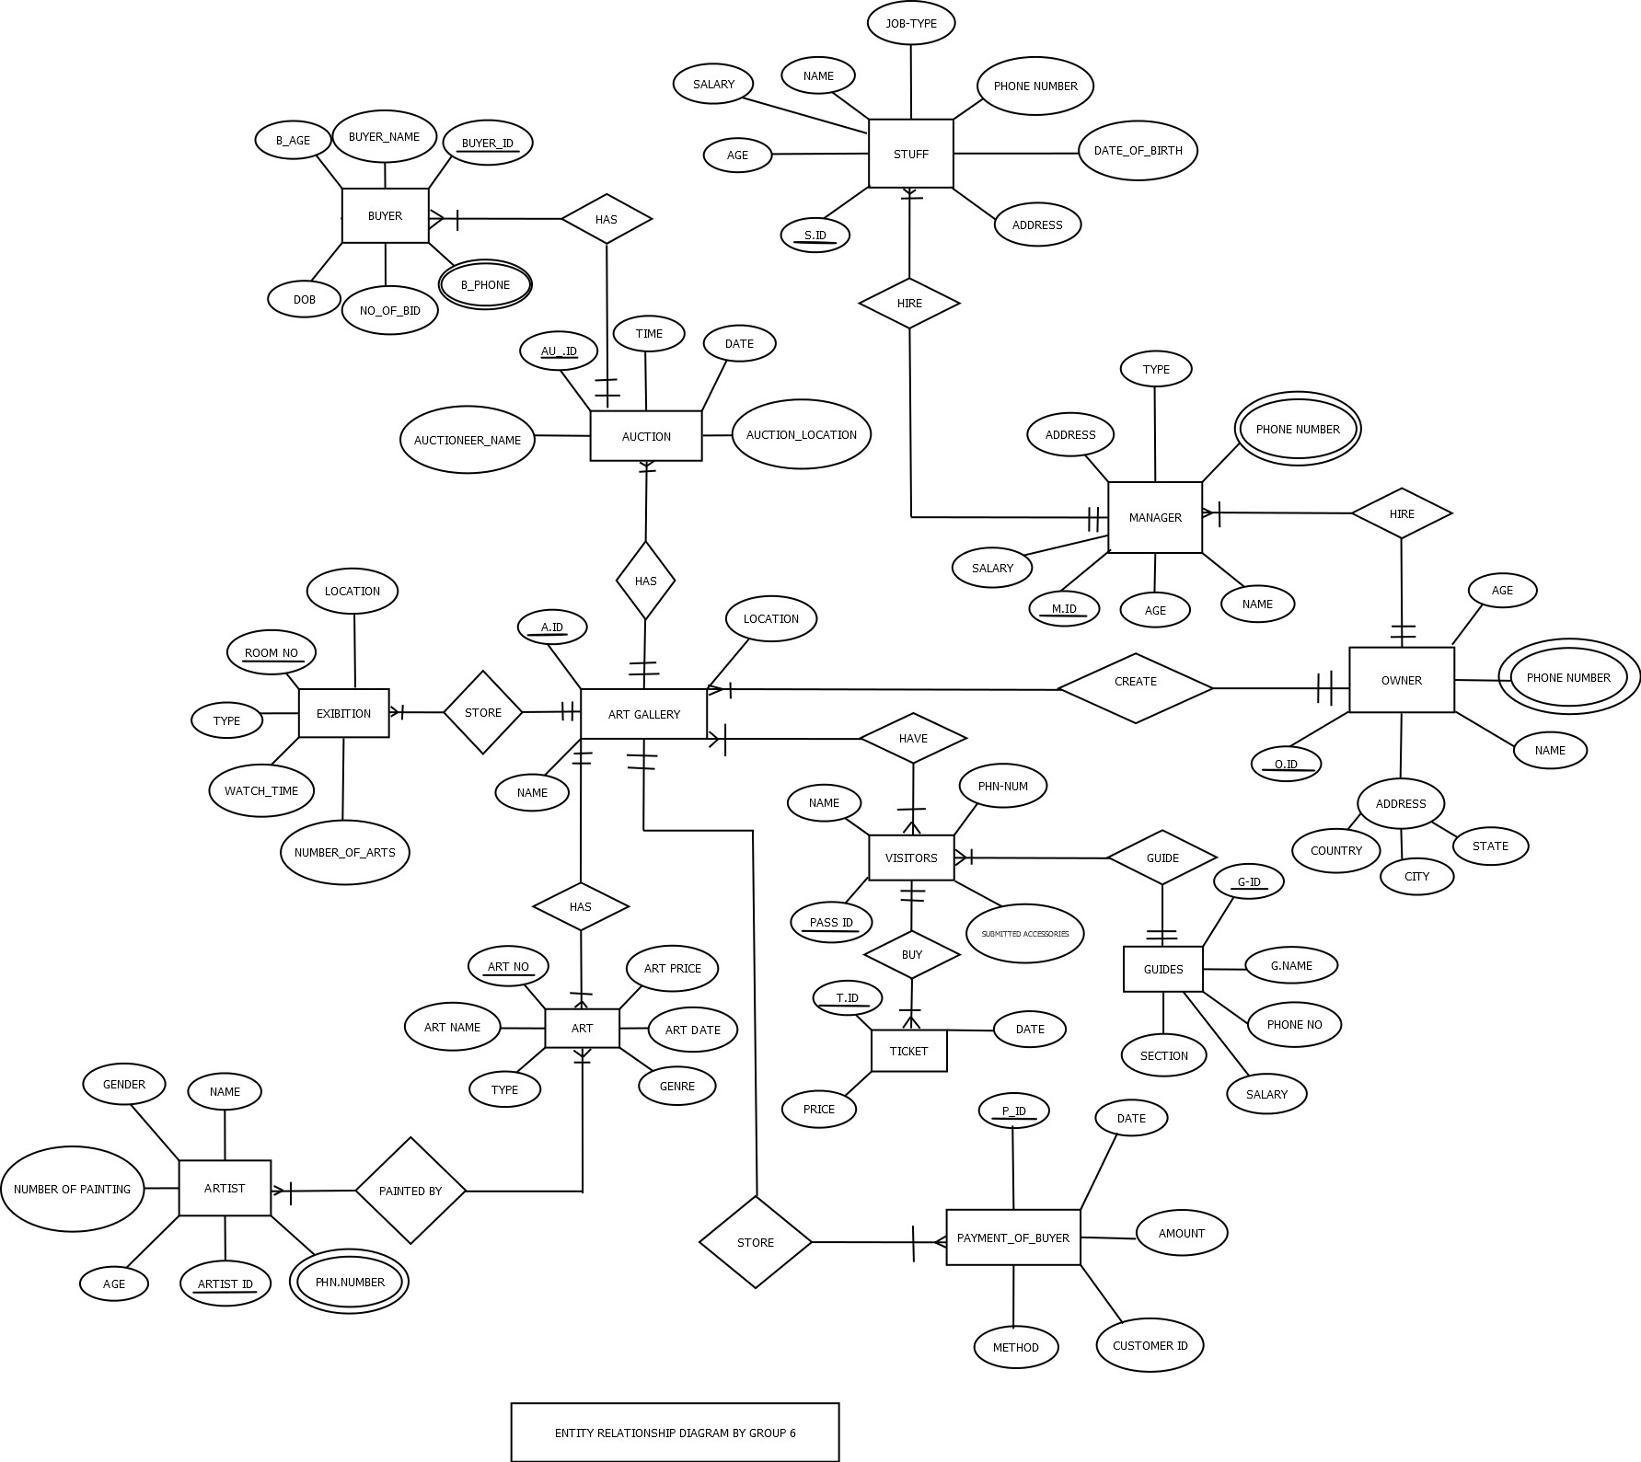

## NORMALIZATION



**HIRE** ( S ID , AGE , DATE_OF_BIRTH , SALARY , NAME , ADDRESS , PHONE_NUMBER ,JOB TYPE, SECURITY , M ID , NAME , AGE , SALARY , TYPE , ADDRESS , PHONE_NUMBER )

**1NF :** PHONE_NUMBER MULTIVALUED ATTRIBUTE

**2NF :** S ID , AGE , DATE_OF_BIRTH , SALARY , NAME , ADDRESS , PHONE_NUMBER ,JOB

TYPE M_ID

M ID , NAME , AGE , SALARY , TYPE , ADDRESS , PHONE_NUMBER

**3NF :** S ID , SALARY , NAME , ADDRESS , PHONE_NUMBER,JOB TYPE

AD_ID , M_ID

M ID , NAME , AGE , SALARY , TYPE , ADDRESS , PHONE_NUMBER

AD ID , AGE , DATE_OF_BIRTH

**TABLE :** S ID , SALARY , NAME , ADDRESS , PHONE_NUMBER ,JOB,TYPE

AD_ID , M_ID

M ID , NAME , AGE , SALARY , TYPE , ADDRESS , PHONE_NUMBER

AD ID , AGE , DATE_OF_BIRTH

**HIRE** ( M ID , NAME , AGE , SALARY , TYPE , ADDRESS , PHONE_NUMBER , O ID , NAME , AGE , PHONE_NUMBER , CITY , COUNTRY , STATE )

**1NF :** PHONE_NUMBER , MULTIVALUED ATTRIBUTE

**2NF :** M ID , NAME , AGE , SALARY , TYPE , ADDRESS , PHONE_NUMBER , O_ID

O ID , NAME , AGE , PHONE_NUMBER , CITY , COUNTRY , STATE

**3NF :** M ID , NAME , AGE , SALARY , TYPE , ADDRESS , PHONE_NUMBER , O_ID

O ID , NAME , AGE , PHONE_NUMBER , T_ID

T ID , CITY , COUNTRY , STATE

**TABLE :** M ID , NAME , AGE , SALARY , TYPE , ADDRESS , PHONE_NUMBER , O_ID

O ID , NAME , AGE , PHONE_NUMBER , T_ID

T ID , CITY , COUNTRY , STATE

**CREATE** ( O ID , NAME , AGE , PHONE_NUMBER , CITY , COUNTRY , STATE , A ID , LOCATION , NAME )

**1NF :** PHONE_NUMBER , MULTIVALUED ATTRIBUTE

**2NF :** O ID , NAME , AGE , PHONE_NUMBER , CITY , COUNTRY , STATE

A ID , LOCATION , NAME , O_ID

**3NF :** O ID , NAME , AGE , PHONE_NUMBER , T_ID

A ID , LOCATION , NAME , O_ID

T ID , CITY , COUNTRY , STATE

**TABLE :** O ID , NAME , AGE , PHONE_NUMBER , T_ID

A ID , LOCATION , NAME , O_ID

T ID , CITY , COUNTRY , STATE

**HAVE** ( A ID , LOCATION , NAME , PASS ID , NAME , PHN_NUM , SUBMITTED_ACCESSORIES )

**1NF :** NO MULTIVALUED ATTRIBUTE

**2NF :** A ID , LOCATION , NAME

PAAS ID , NAME , PHN_NUM , SUBMITTED_ACCESSORIES

AP ID , A_ID , PASS_ID

**3NF :** NO TRANSITIVE DEPENDENCY

A ID , LOCATION , NAME

PAAS ID , NAME , PHN_NUM , SUBMITTED_ACCESSORIES

AP ID , A_ID , PASS_ID

**TABLE :** A ID , LOCATION , NAME

PAAS ID , NAME , PHN_NUM , SUBMITTED_ACCESSORIES

AP ID , A_ID , PASS_ID

**BUY** ( , PASS ID , NAME , PHN_NUM , SUBMITTED_ACCESSORIES ,TI ID , DATE , PRICE )

**1NF :** NO MULTIVALUED ATTRIBUTE

**2NF :**  PASS ID , NAME , PHN_NUM , SUBMITTED_ACCESSORIES

TI ID , DATE , PRICE , PASS_ID

**3NF :** NO TRANSITIVE DEPENDENCY

PASS ID , NAME , PHN_NUM , SUBMITTED_ACCESSORIES

TI ID , DATE , PRICE , PASS_ID

**TABLE :** PASS ID , NAME , PHN_NUM , SUBMITTED_ACCESSORIES

TI ID , DATE , PRICE , PASS_ID

**GUIDE** ( G ID , G_NAME , SECTION , SALARY , PHONE_NO , PAAS ID , NAME , PHN_NUM , SUBMITTED_ACCESSORIES )

**1NF :** NO MULTIVALUED ATTRIBUTE

**2NF :** PAAS ID , NAME , PHN_NUM , SUBMITTED_ACCESSORIES , G_ID

G ID , G_NAME , SECTION , SALARY , PHONE_NO

**3NF :** NO TRANSITIVE DEPENDENCY

PAAS ID , NAME , PHN_NUM , SUBMITTED_ACCESSORIES , G_ID G ID , G_NAME , SECTION , SALARY , PHONE_NO

**TABLE :** PAAS ID , NAME , PHN_NUM , SUBMITTED_ACCESSORIES , G_ID

G ID , G_NAME , SECTION , SALARY , PHONE_NO

**STORE** ( A ID , NAME , LOCATION , P ID , DATE , AMOUNT , METHOD , CUSTOMER_ID )

**1NF :** NO MULTIVALUED ATTRIBUTE

**2NF :** P ID , DATE , AMOUNT , METHOD , CUSTOMER_ID

A ID , NAME , LOCATION

**3NF :** NO TRANSITIVE DEPENDENCY

P ID , DATE , AMOUNT , METHOD , CUSTOMER_ID , A_ID A ID , NAME , LOCATION

**TABLE :** P ID , DATE , AMOUNT , METHOD , CUSTOMER_ID , A_ID

A ID , NAME , LOCATION

**HAS** ( A ID , NAME , LOCATION , ART NO , ART_NAME , ART_DATE , ART_PRICE , TYPE , GENRE )

**1NF :** NO MULTIVALUED ATTRIBUTE

**2NF :** A ID , NAME , LOCATION

ART NO , ART_NAME , ART_DATE , ART_PRICE , TYPE , GENRE , A_ID

**3NF :** NO TRANSITIVE DEPENDENCY

A ID , NAME , LOCATION

ART NO , ART_NAME , ART_DATE , ART_PRICE , TYPE , GENRE , A_ID

**TABLE :** A ID , NAME , LOCATION

ART NO , ART_NAME , ART_DATE , ART_PRICE , TYPE , GENRE , A_ID

**PAINTED BY** ( ART NO , ART_NAME , ART_DATE , ART_PRICE , TYPE , GENRE , ARTIST ID , NUMBER_OF_PAINTING , NAME , AGE , GENDER , PHN_NUMBER )

**1NF :** PHN_NUMBER MULTIVALUED ATTRIBUTE

**2NF :** ART NO , ART_NAME , ART_DATE , ART_PRICE , TYPE , GENRE

ARTIST ID , NUMBER_OF_PAINTING , NAME , AGE , GENDER , PHN_NUMBER

AR ID , ART_NO , ARTIST_ID

**3NF :** NO TRANSITIVE DEPENDENCY

ART NO , ART_NAME , ART_DATE , ART_PRICE , TYPE , GENRE

ARTIST ID , NUMBER_OF_PAINTING , NAME , AGE , GENDER , PHN_NUMBER

AR ID , ART_NO , ARTIST_ID

**TABLE :** ART NO , ART_NAME , ART_DATE , ART_PRICE , TYPE , GENRE

ARTIST ID , NUMBER_OF_PAINTING , NAME , AGE , GENDER , PHN_NUMBER AR ID , ART_NO , ARTIST_ID

**STORE** ( A ID , NAME , LOCATION , ROOM NO , LOCATION , TYPE , WATCH_TIME ,

NUMBER_OF_ART )

**1NF :** NO MULTIVALUED ATTRIBUTE

**2NF :** A ID , NAME , LOCATION

ROOM NO , LOCATION , TYPE , WATCH_TIME , NUMBER_OF_ART , A_ID

**3NF :** NO TRANSITIVE DEPENDENCY

A ID , NAME , LOCATION

ROOM NO , LOCATION , TYPE , WATCH_TIME , NUMBER_OF_ART , A_ID

**TABLE :** A ID , NAME , LOCATION

ROOM NO , LOCATION , TYPE , WATCH_TIME , NUMBER_OF_ART , A_ID

**HAS** ( A ID , NAME , LOCATION , AU ID , TIME , DATE , AUCTION_LOCATION ,

AUCTIONEER_NAME )

**1NF :** NO MULTIVALUED ATTRIBUTE

**2NF :** A ID , NAME , LOCATION ,

AU ID , TIME , DATE , AUCTION_LOCATION , AUCTIONER_NAME , A_ID

**3NF :** NO TRANSITIVE DEPENDENCY

A ID , NAME , LOCATION ,

AU ID , TIME , DATE , AUCTION_LOCATION , AUCTIONER_NAME , A_ID

**TABLE :** A ID , NAME , LOCATION ,

AU ID , TIME , DATE , AUCTION_LOCATION , AUCTIONER_NAME , A_ID

**HAS** ( AU ID , TIME , DATE , AUCTION_LOCATION , AUCTIONER_NAME , BUYER ID ,

BUYER_NAME , NO_OF_BID , B_PHONE , B_AGE , DOB )

**1NF :** B_PHONE MULTIVALUED ATTRIBUTE

**2NF :** AU ID , TIME , DATE , AUCTION_LOCATION , AUCTIONER_NAME

BUYER ID , BUYER_NAME , NO_OF_BID , B_PHONE , B_AGE , DOB , AU_ID

**3NF :** NO TRANSITIVE DEPENDENCY

AU ID , TIME , DATE , AUCTION_LOCATION , AUCTIONER_NAME

BUYER ID , BUYER_NAME , NO_OF_BID , B_PHONE , B_AGE , DOB , AU_ID

**TABLE :** AU ID , TIME , DATE , AUCTION_LOCATION , AUCTIONER_NAME

BUYER ID , BUYER_NAME , NO_OF_BID , B_PHONE , B_AGE , DOB , AU_ID

**TOTAL TABLE :**

1. S ID ,SALARY , NAME , ADDRESS , PHONE_NUMBER ,JOB TYPE, AD_ID , M_ID

2. M ID , NAME , AGE , SALARY , TYPE , ADDRESS , PHONE_NUMBER

1. AD ID , AGE , DATE_OF_BIRTH
2. M ID , NAME , AGE , SALARY , TYPE , ADDRESS , PHONE_NUMBER , O_ID
3. O ID , NAME , AGE , PHONE_NUMBER , T_ID
4. T ID , CITY , COUNTRY , STATE
5. O ID , NAME , AGE , PHONE_NUMBER , T_ID
6. A ID , LOCATION , NAME , 0_ID
7. T ID , CITY , COUNTRY , STATE
8. A ID , LOCATION , NAME X
9. PAAS ID , NAME , PHN_NUM , SUBMITTED_ACCESSORIES
10. AP ID , A_ID , PASS_ID
11. PASS ID , NAME , PHN_NUM , SUBMITTED_ACCESSORIES

14. TI ID , DATE , PRICE , PASS_ID X

1. PAAS ID , NAME , PHN_NUM , SUBMITTED_ACCESSORIES , G_ID
2. G ID , G_NAME , SECTION , SALARY , PHONE_NO
3. P ID , DATE , AMOUNT , METHOD , CUSTOMER_ID , A_ID

18. A ID , NAME , LOCATION

19. A ID , NAME , LOCATION

20. ART NO , ART_NAME , ART_DATE , ART_PRICE , TYPE , GENRE , A_ID

21. ART NO , ART_NAME , ART_DATE , ART_PRICE , TYPE , GENRE X

1. ARTIST ID , NUMBER_OF_PAINTING , NAME , AGE , GENDER , PHN_NUMBER
2. AR ID , ART_NO , ARTIST_ID

24. A ID , NAME , LOCATION

25. ROOM NO , LOCATION , TYPE , WATCH_TIME , NUMBER_OF_ART , A_ID

26.A ID , NAME , LOCATION , X

27.AU ID , TIME , DATE , AUCTION_LOCATION , AUCTIONER_NAME , A_ID

28. AU ID , TIME , DATE , AUCTION_LOCATION , AUCTIONER_NAME X

29. BUYER ID , BUYER_NAME , NO_OF_BID , B_PHONE , B_AGE , DOB , AU_ID

**FINAL TABLE :**

1S ID , SALARY , NAME , ADDRESS , PHONE_NUMBER,JOB TYPE,AD_ID , M_ID

1. M ID , NAME , AGE , SALARY , TYPE , ADDRESS , PHONE_NUMBER , O_ID
2. AD ID , AGE , DATE_OF_BIRTH
3. O ID , NAME , AGE , PHONE_NUMBER , T_ID
4. T ID , CITY , COUNTRY , STATE
5. A ID , LOCATION , NAME , 0_ID
6. AP ID , A_ID , PASS_ID
7. PAAS ID , NAME , PHN_NUM , SUBMITTED_ACCESSORIES , G_ID
8. G ID , G_NAME , SECTION , SALARY , PHONE_NO
9. P ID , DATE , AMOUNT , METHOD , CUSTOMER_ID , A_ID
10. ART NO , ART_NAME , ART_DATE , ART_PRICE , TYPE , GENRE , A_ID
11. ARTIST ID , NUMBER_OF_PAINTING , NAME , AGE , GENDER , PHN_NUMBER
12. AR ID , ART_NO , ARTIST_ID
13. ROOM NO , LOCATION , TYPE , WATCH_TIME , NUMBER_OF_ART , A_ID
14. AU ID , TIME , DATE , AUCTION_LOCATION , AUCTIONER_NAME , A_ID
15. BUYER ID , BUYER_NAME , NO_OF_BID , B_PHONE , B_AGE , DOB , AU_ID

**TABLE CREATION SQL**

* **TABLE NO.01:**

CREATE TABLE STUFF

(S_ID NUMBER (10),SALARY NUMBER (10),NAME VARCHAR2(50),ADDRESS VARCHAR2 (50),

PHONE_NUMBER NUMBER (12),AD_ID NUMBER (10) CONSTRAINT AD_ID_FK REFERENCES AGE_DATE

(AD_ID),M_ID NUMBER (10) CONSTRAINT M_ID_FK REFERENCES MANAGER(M_ID),PRIMARY KEY

(S_ID));

DESC STUFF;

* **TABLE NO.02:**

CREATE TABLE MANAGER (M_ID NUMBER (5),NAME VARCHAR2 (50),AGE NUMBER (5),SALARY NUMBER

(10),

TYPE VARCHAR2(50),ADDRESS VARCHAR2 (50),PHONE_NUMBER NUMBER (12),O_ID NUMBER (5) CONSTRAINT O_ID_FK REFERENCES OWNER (O_ID),PRIMARY KEY (M_ID));

DESC MANAGER

* **TABLE NO.03:**

CREATE TABLE AGE_DATE (AD_ID NUMBER (5),AGE NUMBER (5),DATE_OF_BIRTH DATE,PRIMARY KEY (AD_ID));

DESC AGE_DATE ;

* **TABLE NO.04:**

CREATE TABLE OWNER (O_ID NUMBER (5),NAME VARCHAR2(50),AGE NUMBER (5),PHONE_NUMBER

NUMBER (12),T_ID NUMBER (5) CONSTRAINT T_ID_FK REFERENCES OWNER_ADDRESS (T_ID) ,PRIMARY KEY (O_ID));

DESC OWNER ;

* **TABLE NO.05:**

CREATE TABLE OWNER_ADDRESS (T_ID NUMBER (5),CITY VARCHAR2 (50), COUNTRY VARCHAR2(50), LOCATION VARCHAR2 (50),PRIMARY KEY (T_ID))

DESC OWNER_ADDRESS

* **TABLE NO.06:**

CREATE TABLE ART_GALLERY (A_ID NUMBER (5),NAME VARCHAR2 (50), LOCATION VARCHAR2(50), O_ID

NUMBER (5) CONSTRAINT O_ID_FK1 REFERENCES OWNER (O_ID),PRIMARY KEY (A_ID)); DESC ART_GALLERY

* **TABLE NO.07:**

CREATE TABLE GALLERY_VISITORS (AP_ID NUMBER (5), A_ID NUMBER(5), PASS_ID NUMBER (5) , PRIMARY KEY (AP_ID));

DESC TABLE

* **TABLE NO.08:**

CREATE TABLE VISITORS (PASS_ID NUMBER (5), NAME VARCHAR2 (50), PHONE_NUMBER NUMBER (12),

SUBMITTED_ACCESSORIES VARCHAR2 (50),G_ID NUMBER (5) CONSTRAINT G_ID_FK REFERENCES

GUIDES (G_ID),PRIMARY KEY (PASS_ID));

DESC VISITORS

* **TABLE NO.09:**

CREATE TABLE GUIDES (G_ID NUMBER (5),G_NAME VARCHAR2 (50),SECTION NUMBER (5), SALARY

NUMBER (10), PHONE_NUMBER NUMBER (12),PRIMARY KEY (G_ID));

DESC GUIDES

* **TABLE NO.10**

CREATE TABLE PAYMENT_OF_BUYER (P_ID NUMBER (5),PAYMENT_DATE DATE , AMOUNT NUMBER

(10), METHOD VARCHAR2 (20),CUSTOMER_ID NUMBER (5) ,A_ID NUMBER (5) CONSTRAINT A_ID_FK REFERENCES ART_GALLERY (A_ID), PRIMARY KEY (P_ID));

DESC PAYMENT_OF_BUYER

* **TABLE NO.11:**

CREATE TABLE ART (ART_NO NUMBER (5), ART_NAME VARCHAR2 (50), ART_DATE DATE ,ART_PRICE

NUMBER (10),TYPE VARCHAR2(50),GENRE VARCHAR2 (50),A_ID NUMBER (5) CONSTRAINT A_ID_FK2

REFERENCES ART_GALLERY (A_ID), PRIMARY KEY (ART_NO ));

DESC ART

* **TABLE NO.12:**

CREATE TABLE ARTIST (ARTIST_ID NUMBER (5),NUMBER_OF_PAINTING NUMBER (5),NAME VARCHAR2

(50), AGE NUMBER (5), GENDER VARCHAR2 (2),PHONE_NUMBER NUMBER (12)); DESC ARTIST

* **TABLE NO.13:**

CREATE TABLE ART_ARTIST (AR_ID NUMBER (5) , ART_NO NUMBER (5), ARTIST NUMBER (5), PRIMARY KEY (AR_ID));

DESC ART_ARTIST

* **TABLE NO.14:**

CREATE TABLE EXIBITION (ROOM_NO NUMBER (5), LOCATION VARCHAR2 (50),WATCH_TIME NUMBER

(10), NUMBER_OF_ART NUMBER (10),A_ID NUMBER (5), PRIMARY KEY (ROOM_NO));

DESC EXIBITION

* **TABLE NO.15:**

CREATE TABLE AUCTION (AU_ID NUMBER (5),TIME NUMBER (10), AUCTION_DATE DATE

,AUCTION_LOCATION VARCHAR2 (50), AUCTIONEER_NAME VARCHAR2 (50),A_ID NUMBER (5) CONSTRAINT A_ID_FK3 REFERENCES ART_GALLERY (A_ID), PRIMARY KEY (AU_ID));

DESC AUCTION

* **TABLE NO.16:**

CREATE TABLE BUYER (BUYER_ID NUMBER (5), BUYER_NAME VARCHAR2 (50),NO_OF_BID NUMBER

(5),B_PHONE NUMBER (12),B_AGE NUMBER (5),B_DOB DATE ,AU_ID NUMBER (5) CONSTRAINT

AU_ID_FK REFERENCES AUCTION (AU_ID), PRIMARY KEY (BUYER_ID));

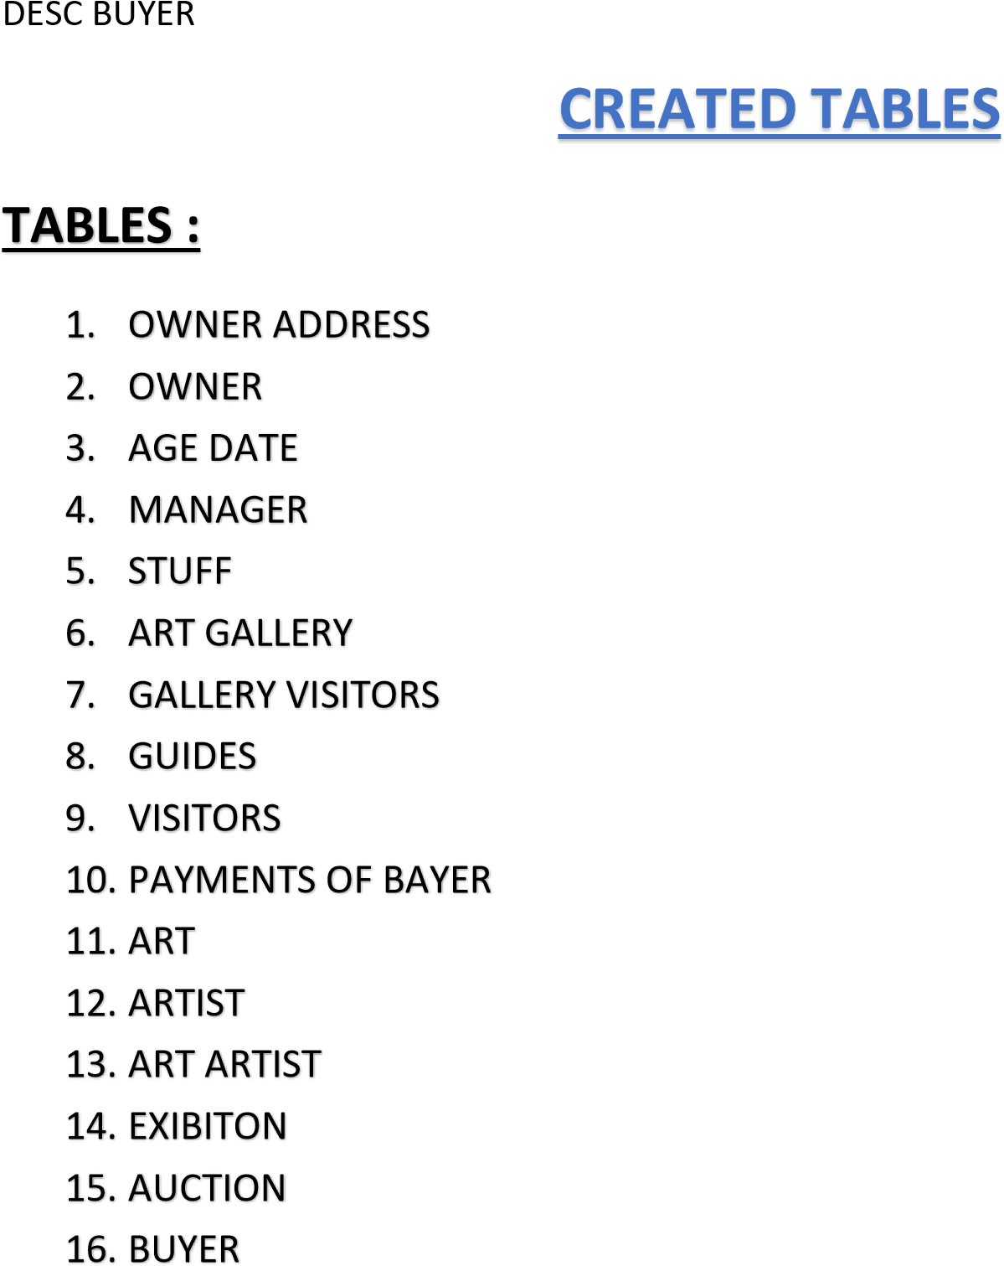

1 . STUFF

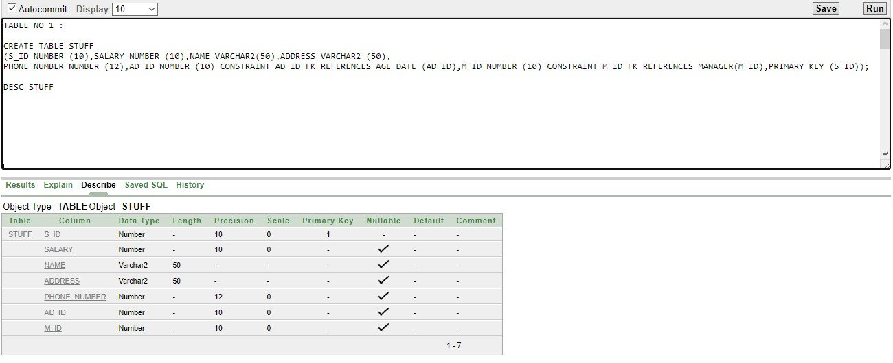

2

.MANGER

3

.AGE_DATE

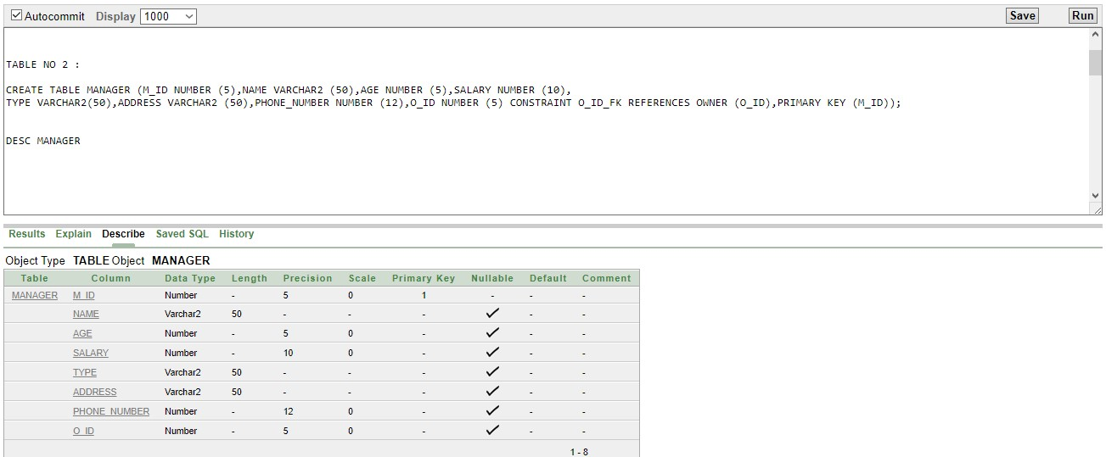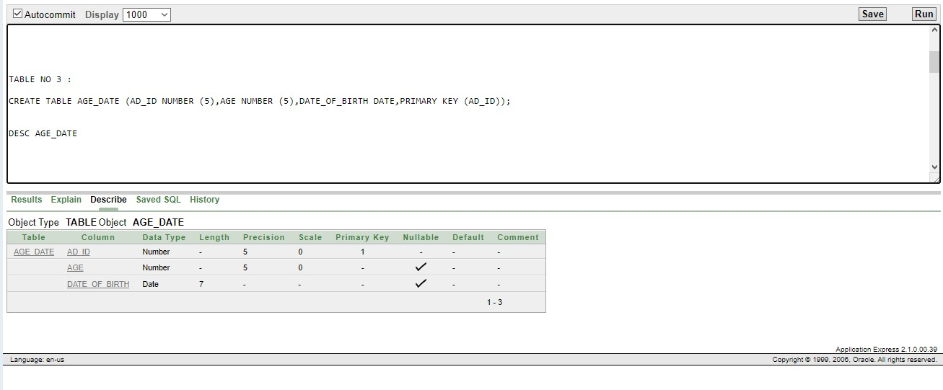

4.ONWER

5

.OWNER ADDRESS

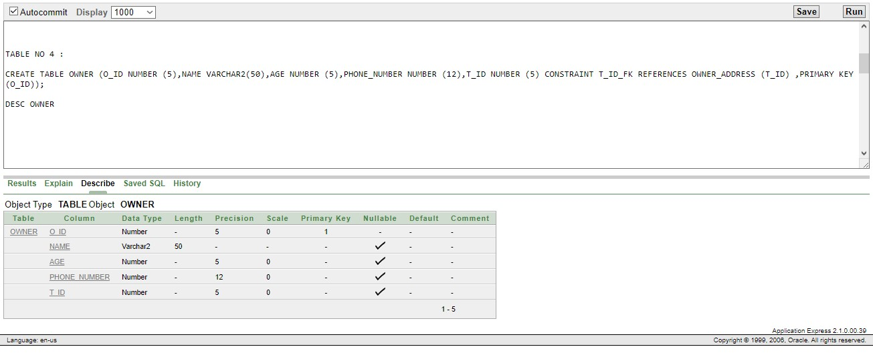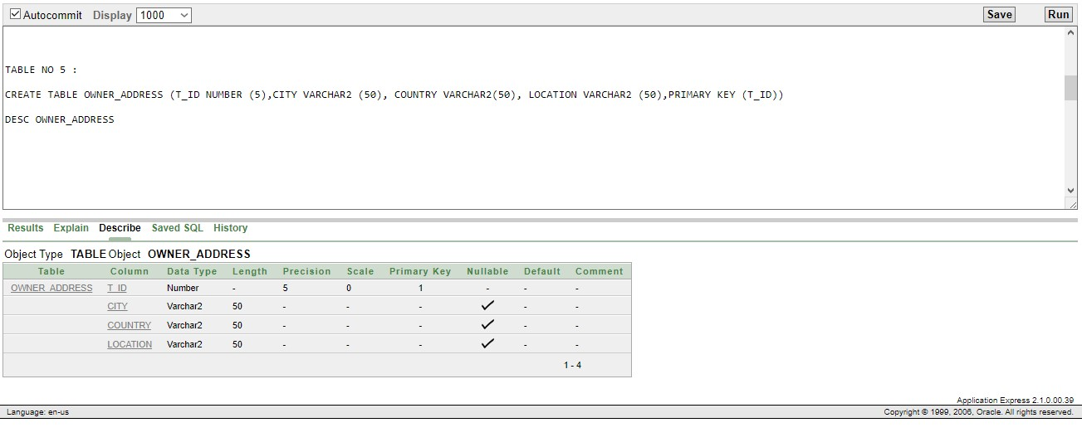

6

.ART GALLERY

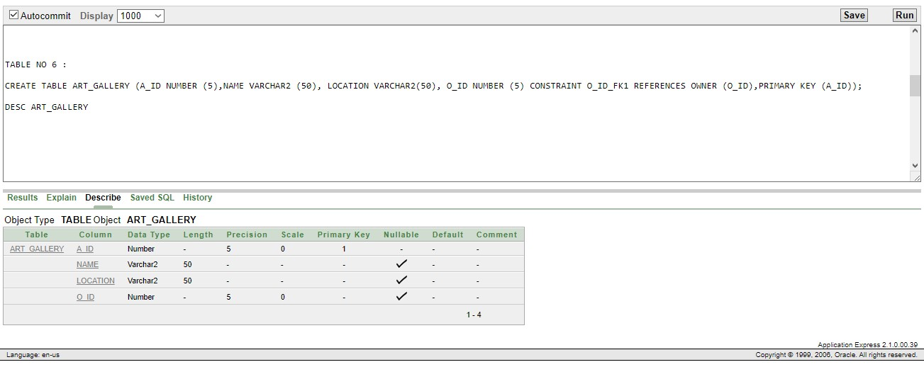

7.GALLERY VISITORS

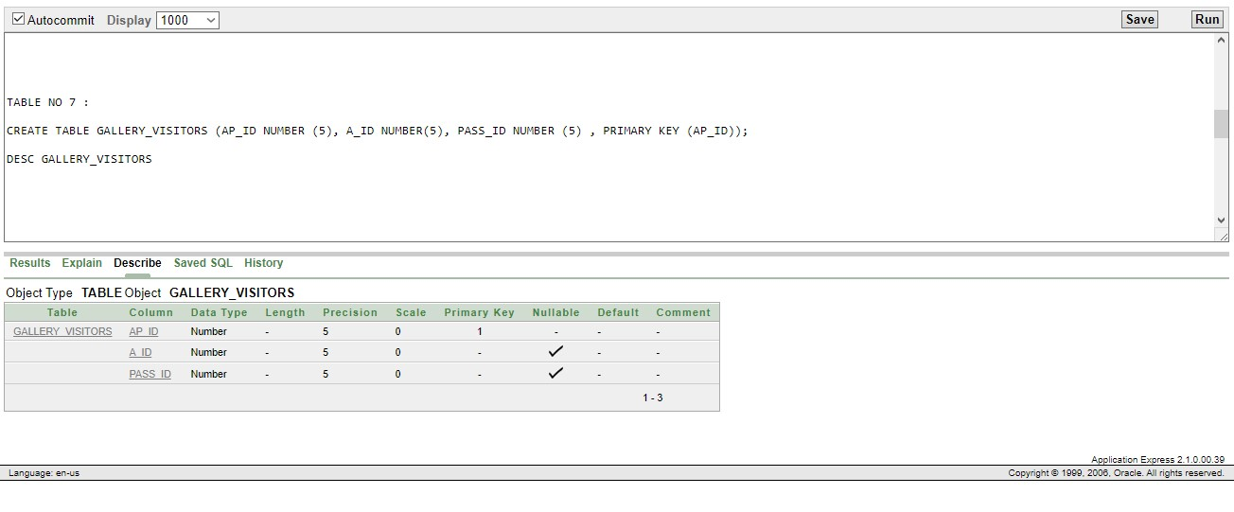

8.VISITORS

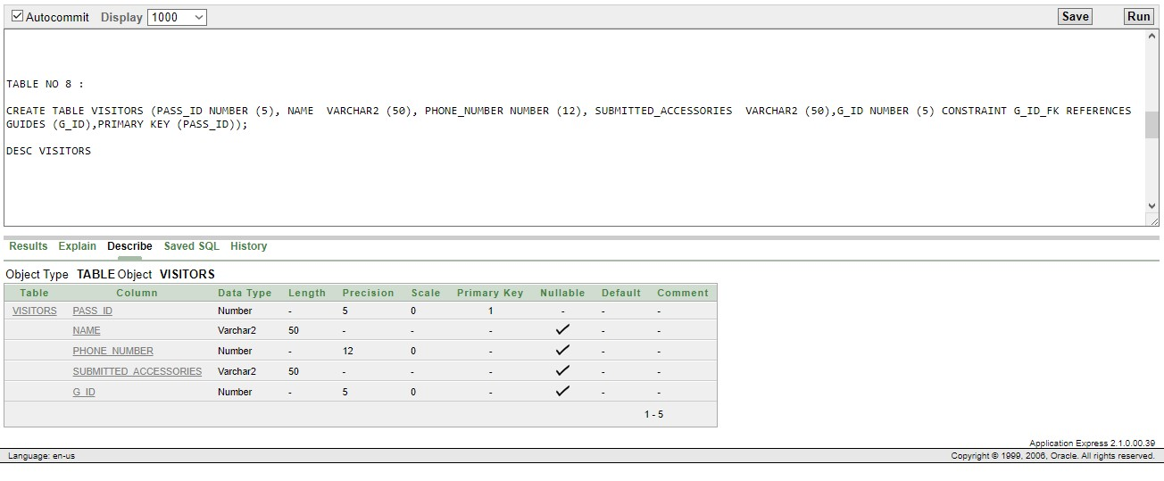

9.GUIDES

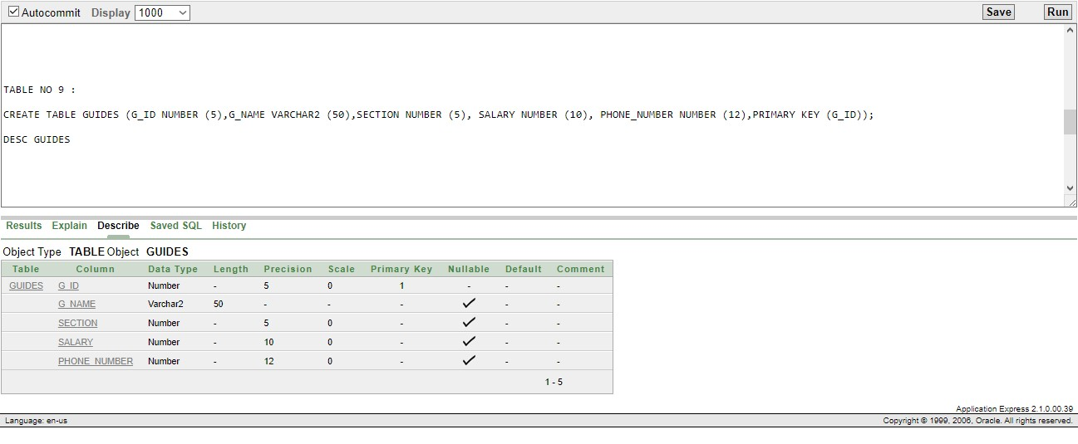

10.PAYMENT OF BUYER

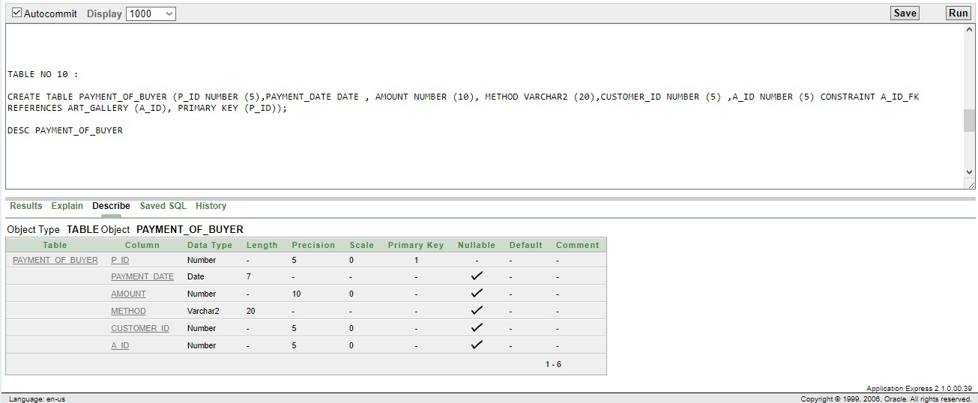

11.ART

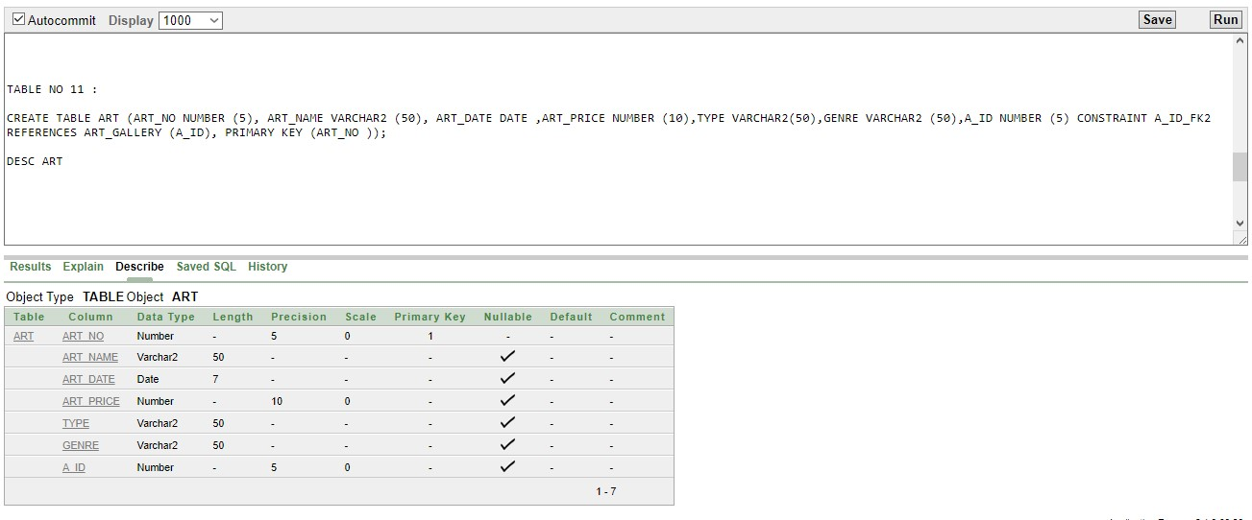

12.ARTIST

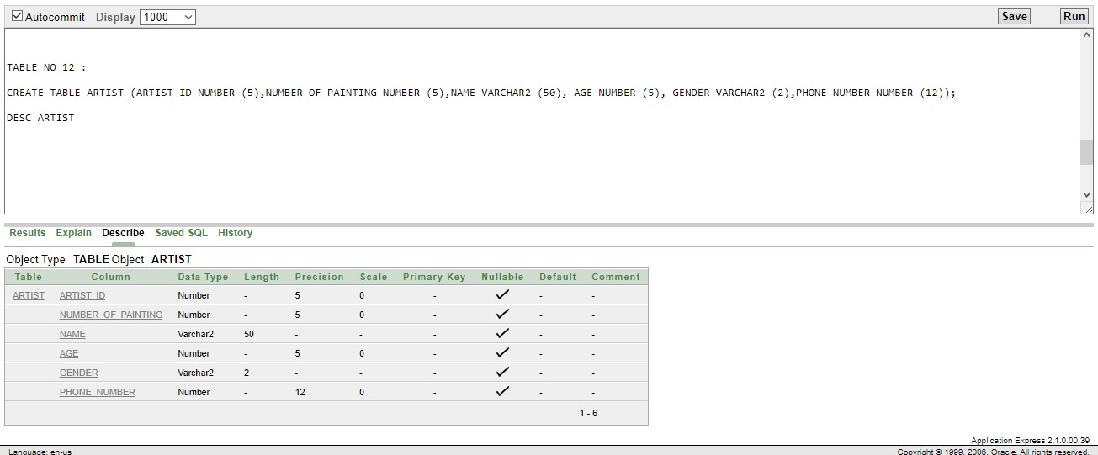

13.ART ARTIST

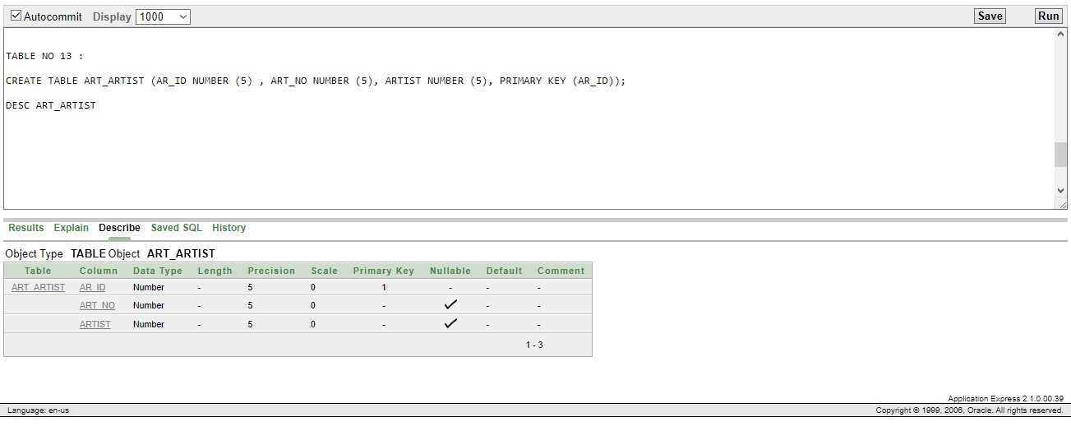

14.EXIBITION

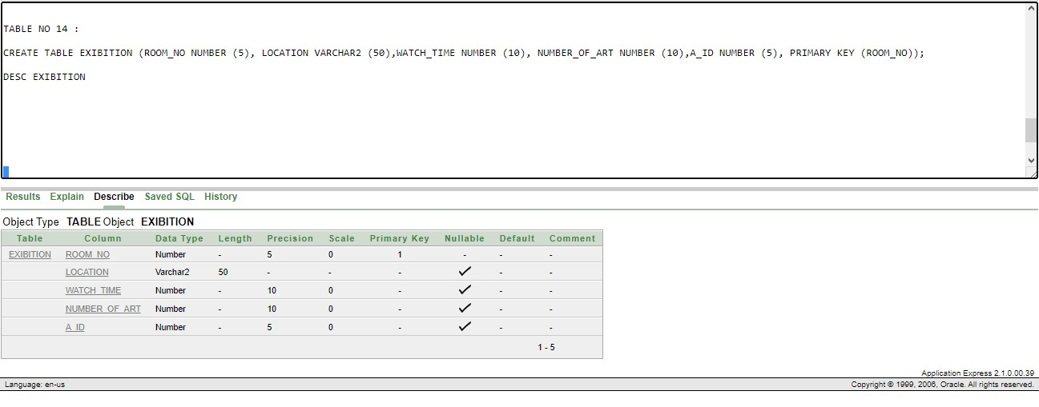

15.AUCTION

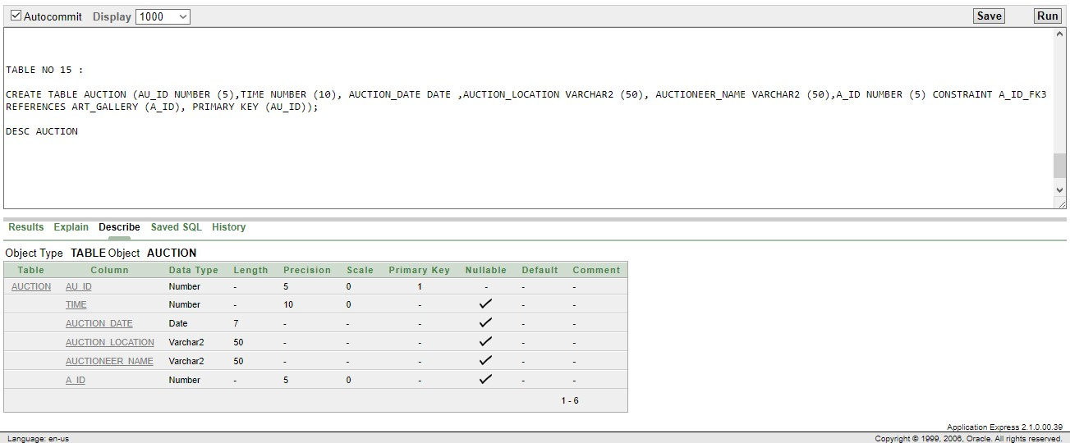

16 .BUYER

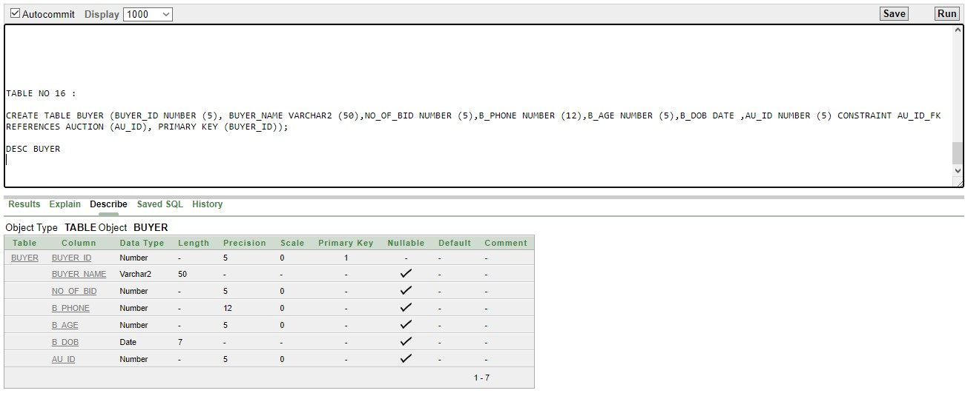

**DATA INSERTION SQL**

**GUIDES:**

CREATE SEQUENCE G_ID

INCREMENT BY 1

START WITH 01

MAXVALUE 100;

INSERT INTO GUIDES (G_ID,G_NAME,SECTION,SALARY,PHONE_NUMBER) VALUES (G_ID.NEXTVAL,'ABDULLAH',1,10000,1234567)

INSERT INTO GUIDES (G_ID,G_NAME,SECTION,SALARY,PHONE_NUMBER) VALUES (G_ID.NEXTVAL,'ABDULLA',2,30000,1234467)

INSERT INTO GUIDES (G_ID,G_NAME,SECTION,SALARY,PHONE_NUMBER) VALUES (G_ID.NEXTVAL,'NEHA',2,20000,4367783)

INSERT INTO GUIDES (G_ID,G_NAME,SECTION,SALARY,PHONE_NUMBER) VALUES (G_ID.NEXTVAL,'RAJ',12,4000,134567)

INSERT INTO GUIDES (G_ID,G_NAME,SECTION,SALARY,PHONE_NUMBER) VALUES (G_ID.NEXTVAL,'MAYAD',4,30000,12367)

INSERT INTO GUIDES (G_ID,G_NAME,SECTION,SALARY,PHONE_NUMBER) VALUES (G_ID.NEXTVAL,'MANHA',8,320000,1457)

INSERT INTO GUIDES (G_ID,G_NAME,SECTION,SALARY,PHONE_NUMBER) VALUES (G_ID.NEXTVAL,'ALIF',45,100400,463673)

INSERT INTO GUIDES (G_ID,G_NAME,SECTION,SALARY,PHONE_NUMBER) VALUES (G_ID.NEXTVAL,'FARHAN',45,50000,77)

INSERT INTO GUIDES (G_ID,G_NAME,SECTION,SALARY,PHONE_NUMBER) VALUES (G_ID.NEXTVAL,'ALIN',1,100,12341347)

INSERT INTO GUIDES (G_ID,G_NAME,SECTION,SALARY,PHONE_NUMBER) VALUES (G_ID.NEXTVAL,'ALEX',1,132000,4567)

SELECT * FROM GUIDES

**VISITORS:**

CREATE SEQUENCE V_ID

INCREMENT BY 1

START WITH 01

MAXVALUE 100;

INSERT INTO VISITORS (PASS_ID,NAME,PHONE_NUMBER,SUBMITTED_ACCESSORIES,G_ID) VALUES(1,'ABDULLAH',01743252585,'BAG',V_ID.NEXTVAL)

INSERT INTO VISITORS (PASS_ID,NAME,PHONE_NUMBER,SUBMITTED_ACCESSORIES,G_ID) VALUES(2,'NEHA',01743252456,'PURSE',V_ID.NEXTVAL)

INSERT INTO VISITORS (PASS_ID,NAME,PHONE_NUMBER,SUBMITTED_ACCESSORIES,G_ID) VALUES(3,'MAYAD',01743252346,'MOBILE',V_ID.NEXTVAL)

INSERT INTO VISITORS (PASS_ID,NAME,PHONE_NUMBER,SUBMITTED_ACCESSORIES,G_ID) VALUES(4,'RAJ',017472523432,'BAG',V_ID.NEXTVAL)

INSERT INTO VISITORS (PASS_ID,NAME,PHONE_NUMBER,SUBMITTED_ACCESSORIES,G_ID) VALUES(5,'MANHA',01711190550,'BOTTLE',V_ID.NEXTVAL)

INSERT INTO VISITORS (PASS_ID,NAME,PHONE_NUMBER,SUBMITTED_ACCESSORIES,G_ID) VALUES(6,'ALIF',01799383029,'SHIRT',V_ID.NEXTVAL)

INSERT INTO VISITORS (PASS_ID,NAME,PHONE_NUMBER,SUBMITTED_ACCESSORIES,G_ID) VALUES(7,'ALIN',01721004206,'PANT',V_ID.NEXTVAL)

INSERT INTO VISITORS (PASS_ID,NAME,PHONE_NUMBER,SUBMITTED_ACCESSORIES,G_ID) VALUES(8,'SALMAN KHAN',99127282,'HOUSE',V_ID.NEXTVAL)

INSERT INTO VISITORS (PASS_ID,NAME,PHONE_NUMBER,SUBMITTED_ACCESSORIES,G_ID) VALUES(9,'SHAH RUKH',12384568312,'BAG',V_ID.NEXTVAL)

INSERT INTO VISITORS (PASS_ID,NAME,PHONE_NUMBER,SUBMITTED_ACCESSORIES,G_ID) VALUES(10,'TOM CRUZE',0179625962,'PURSE',3)

SELECT * FROM VISITORS

**ARTIST:**

INSERT INTO ARTIST (ARTIST_ID,NUMBER_OF_PAINTING,NAME,AGE,GENDER,PHONE_NUMBER) VALUES (1,34,'DA VINCHI',88,'M',0174536272)

INSERT INTO ARTIST (ARTIST_ID,NUMBER_OF_PAINTING,NAME,AGE,GENDER,PHONE_NUMBER) VALUES (2,23,'jOYNUL ABEDIN',12,'M',01624638523)

INSERT INTO ARTIST (ARTIST_ID,NUMBER_OF_PAINTING,NAME,AGE,GENDER,PHONE_NUMBER) VALUES (3,12,'MAYAD',21,'F',016734728526)

INSERT INTO ARTIST (ARTIST_ID,NUMBER_OF_PAINTING,NAME,AGE,GENDER,PHONE_NUMBER) VALUES (4,1,'NEHA',22,'F',01634627827)

INSERT INTO ARTIST (ARTIST_ID,NUMBER_OF_PAINTING,NAME,AGE,GENDER,PHONE_NUMBER) VALUES (5,1,'ABDULLAH',23,'M',01743252585)

INSERT INTO ARTIST (ARTIST_ID,NUMBER_OF_PAINTING,NAME,AGE,GENDER,PHONE_NUMBER) VALUES (6,2,'RAJ',19,'M',04537253793)

INSERT INTO ARTIST (ARTIST_ID,NUMBER_OF_PAINTING,NAME,AGE,GENDER,PHONE_NUMBER) VALUES (7,4,'ALIN',56,'M',01638453273)

INSERT INTO ARTIST (ARTIST_ID,NUMBER_OF_PAINTING,NAME,AGE,GENDER,PHONE_NUMBER) VALUES (8,34,'ALEX',34,'M',2563973627)

INSERT INTO ARTIST (ARTIST_ID,NUMBER_OF_PAINTING,NAME,AGE,GENDER,PHONE_NUMBER) VALUES (9,6,'GAYLE',23,'F',01734264532)

INSERT INTO ARTIST (ARTIST_ID,NUMBER_OF_PAINTING,NAME,AGE,GENDER,PHONE_NUMBER) VALUES (10,9,'JENIFFER',25,'F',018352654835)

SELECT * FROM ARTIST

**ART_ARTIST:**

CREATE SEQUENCE AR_ID

INCREMENT BY 1

START WITH 01

MAXVALUE 10;

INSERT INTO ART_ARTIST (AR_ID,ART_NO,ARTIST) VALUES(AR_ID.NEXTVAL,234,12)

INSERT INTO ART_ARTIST (AR_ID,ART_NO,ARTIST) VALUES(AR_ID.NEXTVAL,23,1)

INSERT INTO ART_ARTIST (AR_ID,ART_NO,ARTIST) VALUES(AR_ID.NEXTVAL,34,1221)

INSERT INTO ART_ARTIST (AR_ID,ART_NO,ARTIST) VALUES(AR_ID.NEXTVAL,4,44)

INSERT INTO ART_ARTIST (AR_ID,ART_NO,ARTIST) VALUES(AR_ID.NEXTVAL,619,42)

INSERT INTO ART_ARTIST (AR_ID,ART_NO,ARTIST) VALUES(AR_ID.NEXTVAL,456,66)

INSERT INTO ART_ARTIST (AR_ID,ART_NO,ARTIST) VALUES(AR_ID.NEXTVAL,324,974)

INSERT INTO ART_ARTIST (AR_ID,ART_NO,ARTIST) VALUES(AR_ID.NEXTVAL,123,876)

INSERT INTO ART_ARTIST (AR_ID,ART_NO,ARTIST) VALUES(AR_ID.NEXTVAL,678,432)

INSERT INTO ART_ARTIST (AR_ID,ART_NO,ARTIST) VALUES(AR_ID.NEXTVAL,999,555)

INSERT INTO ART_ARTIST (AR_ID,ART_NO,ARTIST) VALUES(AR_ID.NEXTVAL,69,96)

SELECT * FROM ART_ARTIST

**OWNER_ADDRESS:**

CREATE SEQUENCE ID

INCREMENT BY 1

START WITH 01

MAXVALUE 10;

INSERT INTO OWNER_ADDRESS(T_ID ,CITY , COUNTRY ,LOCATION) VALUES (ID.NEXTVAL,'DHAKA','BANGLADESH','UTTARA');

INSERT INTO OWNER_ADDRESS(T_ID ,CITY , COUNTRY ,LOCATION) VALUES (ID.NEXTVAL,'DHAKA','BANGLADESH','BANANI');

INSERT INTO OWNER_ADDRESS(T_ID ,CITY , COUNTRY ,LOCATION) VALUES (ID.NEXTVAL,'DHAKA','BANGLADESH','KHILKHET');

INSERT INTO OWNER_ADDRESS(T_ID ,CITY , COUNTRY ,LOCATION) VALUES (ID.NEXTVAL,'DHAKA','BANGLADESH','RAMPURA');

INSERT INTO OWNER_ADDRESS(T_ID ,CITY , COUNTRY ,LOCATION) VALUES (ID.NEXTVAL,'DHAKA','BANGLADESH','BASHUNDHARA');

INSERT INTO OWNER_ADDRESS(T_ID ,CITY , COUNTRY ,LOCATION) VALUES (ID.NEXTVAL,'DHAKA','BANGLADESH','GULSHAN');

INSERT INTO OWNER_ADDRESS(T_ID ,CITY , COUNTRY ,LOCATION) VALUES

(ID.NEXTVAL,'RAJSHAJI','BANGLADESH','MALOPARA');

INSERT INTO OWNER_ADDRESS(T_ID ,CITY , COUNTRY ,LOCATION) VALUES (ID.NEXTVAL,'RAJSHAHI','BANGLADESH','SHALBAGAN');

INSERT INTO OWNER_ADDRESS(T_ID ,CITY , COUNTRY ,LOCATION) VALUES (ID.NEXTVAL,'RAJSHAHI','BANGLADESH','VODRA');

INSERT INTO OWNER_ADDRESS(T_ID ,CITY , COUNTRY ,LOCATION) VALUES (ID.NEXTVAL,'DHAKA','BANGLADESH','UTTARA');

SELECT * FROM OWNER_ADDRESS

**OWNER:**

CREATE SEQUENCE O_ID

INCREMENT BY 1

START WITH 01

MAXVALUE 10;

INSERT INTO OWNER (O_ID,NAME, AGE ,PHONE_NUMBER,T_ID) VALUES (O_ID.NEXTVAL,'MUJAHID RAJ',23,01796059406,1)

INSERT INTO OWNER (O_ID,NAME, AGE ,PHONE_NUMBER,T_ID) VALUES (O_ID.NEXTVAL,'ASMAUL HUSNA MAYAD',24,01786059401,2)

INSERT INTO OWNER (O_ID,NAME, AGE ,PHONE_NUMBER,T_ID) VALUES (O_ID.NEXTVAL,'ABDULLAH KHONDOKAR',25,01796359407,3)

INSERT INTO OWNER (O_ID,NAME, AGE ,PHONE_NUMBER,T_ID) VALUES (O_ID.NEXTVAL,'SARAH BINTE NEHA',21,01796051486,4)

INSERT INTO OWNER (O_ID,NAME, AGE ,PHONE_NUMBER,T_ID) VALUES (O_ID.NEXTVAL,'NADIYA NOOR',22,01776059411,5)

INSERT INTO OWNER (O_ID,NAME, AGE ,PHONE_NUMBER,T_ID) VALUES (O_ID.NEXTVAL,'ALIN DAS',23,01796052486,6)

INSERT INTO OWNER (O_ID,NAME, AGE ,PHONE_NUMBER,T_ID) VALUES (O_ID.NEXTVAL,'FIDBI HOSSAIN',27,0175679402,7)

INSERT INTO OWNER (O_ID,NAME, AGE ,PHONE_NUMBER,T_ID) VALUES (O_ID.NEXTVAL,'AKRAM ALI',36,01796059765,8)

INSERT INTO OWNER (O_ID,NAME, AGE ,PHONE_NUMBER,T_ID) VALUES (O_ID.NEXTVAL,'MOMIN ALI',29,01796059123,9)

INSERT INTO OWNER (O_ID,NAME, AGE ,PHONE_NUMBER,T_ID) VALUES (10,'KUDDUS KHAN',30,01796059123,10)

SELECT * FROM OWNER

**ART_GALLERY:**

INSERT INTO ART_GALLERY (A_ID,NAME,LOCATION ,O_ID) VALUES (101,'JAHANGIRS','SHIBGANJ',1)

INSERT INTO ART_GALLERY (A_ID,NAME,LOCATION ,O_ID) VALUES (102,'AR GALLERY','SHIBGANJ',2)

INSERT INTO ART_GALLERY (A_ID,NAME,LOCATION ,O_ID) VALUES (103,'AKRAM ART GELLARY','SHIBGANJ',3)

INSERT INTO ART_GALLERY (A_ID,NAME,LOCATION ,O_ID) VALUES (104,'BE ONE ART','UTTARA',4)

INSERT INTO ART_GALLERY (A_ID,NAME,LOCATION ,O_ID) VALUES (105,'YOURS ART ','DHAKA',5)

INSERT INTO ART_GALLERY (A_ID,NAME,LOCATION ,O_ID) VALUES (106,'GALLERY NO 1','DHAKA',6)

INSERT INTO ART_GALLERY (A_ID,NAME,LOCATION ,O_ID) VALUES (107,'NO ONE','GOMOSTAPUR',7)

INSERT INTO ART_GALLERY (A_ID,NAME,LOCATION ,O_ID) VALUES (108,'SAVAGE ART','ROHANPUR',8)

INSERT INTO ART_GALLERY (A_ID,NAME,LOCATION ,O_ID) VALUES (109,'HOUSE OF ART','BARISHAL',9)

INSERT INTO ART_GALLERY (A_ID,NAME,LOCATION ,O_ID) VALUES (110,'JANES','SHEIKHTOLA',10)

SELECT * FROM ART_GALLERY

**GALLERY VISITORS:**

INSERT INTO GALLERY_VISITORS (AP_ID,A_ID,PASS_ID) VALUES (01,101,1)

INSERT INTO GALLERY_VISITORS (AP_ID,A_ID,PASS_ID) VALUES (02,102,2)

INSERT INTO GALLERY_VISITORS (AP_ID,A_ID,PASS_ID) VALUES (03,103,3)

INSERT INTO GALLERY_VISITORS (AP_ID,A_ID,PASS_ID) VALUES (04,104,4)

INSERT INTO GALLERY_VISITORS (AP_ID,A_ID,PASS_ID) VALUES (05,105,5)

INSERT INTO GALLERY_VISITORS (AP_ID,A_ID,PASS_ID) VALUES (06,106,6)

INSERT INTO GALLERY_VISITORS (AP_ID,A_ID,PASS_ID) VALUES (07,107,7)

INSERT INTO GALLERY_VISITORS (AP_ID,A_ID,PASS_ID) VALUES (08,108,8)

INSERT INTO GALLERY_VISITORS (AP_ID,A_ID,PASS_ID) VALUES (09,109,9)

INSERT INTO GALLERY_VISITORS (AP_ID,A_ID,PASS_ID) VALUES (10,110,10)

SELECT * FROM GALLERY_VISITORS

**AGE_DATE:**

INSERT INTO AGE_DATE (AD_ID, AGE ,DATE_OF_BIRTH) VALUES (10,23,'01-JAN-2001')

INSERT INTO AGE_DATE (AD_ID, AGE ,DATE_OF_BIRTH) VALUES (11,23,'13-JAN-1999')

INSERT INTO AGE_DATE (AD_ID, AGE ,DATE_OF_BIRTH) VALUES (12,29,'02-JAN-2000')

INSERT INTO AGE_DATE (AD_ID, AGE ,DATE_OF_BIRTH) VALUES (13,26,'06-JUN-2001')

INSERT INTO AGE_DATE (AD_ID, AGE ,DATE_OF_BIRTH) VALUES (14,25,'14-JAN-1998') INSERT INTO AGE_DATE (AD_ID, AGE ,DATE_OF_BIRTH) VALUES (15,27,'09-FEB-2002')

INSERT INTO AGE_DATE (AD_ID, AGE ,DATE_OF_BIRTH) VALUES (16,21,'10-JAN-1997')

INSERT INTO AGE_DATE (AD_ID, AGE ,DATE_OF_BIRTH) VALUES (17,30,'23-NOV-2001')

INSERT INTO AGE_DATE (AD_ID, AGE ,DATE_OF_BIRTH) VALUES (18,24,'01-JAN-2001') INSERT INTO AGE_DATE (AD_ID, AGE ,DATE_OF_BIRTH) VALUES (19,22,'15-JAN-2001')

SELECT * FROM AGE_DATE **STUFF:**

CREATE TABLE STUFF

(S_ID NUMBER (10),SALARY NUMBER (10),NAME VARCHAR2(50),ADDRESS VARCHAR2 (50),

PHONE_NUMBER NUMBER (12),AD_ID NUMBER (10) CONSTRAINT AD_ID_FK REFERENCES AGE_DATE

(AD_ID),M_ID NUMBER (10) CONSTRAINT M_ID_FK REFERENCES MANAGER(M_ID),PRIMARY KEY (S_ID)) INSERT INTO STUFF (S_ID,SALARY,NAME,ADDRESS ,PHONE_NUMBER , AD_ID,M_ID) VALUES (111,6000,'RAYHAN','DHAKA',016438386,11,10)

INSERT INTO STUFF (S_ID,SALARY,NAME,ADDRESS ,PHONE_NUMBER , AD_ID,M_ID) VALUES (112,6000,'SOHAN','DHANMONDI',017489233,12,20)

INSERT INTO STUFF (S_ID,SALARY,NAME,ADDRESS ,PHONE_NUMBER , AD_ID,M_ID) VALUES (113,6000,'KEKA','SANTIBAGH',018834053,13,30)

INSERT INTO STUFF (S_ID,SALARY,NAME,ADDRESS ,PHONE_NUMBER , AD_ID,M_ID) VALUES (114,6000,'EYAD','RAYERBAGH',019873450,14,40)

INSERT INTO STUFF (S_ID,SALARY,NAME,ADDRESS ,PHONE_NUMBER , AD_ID,M_ID) VALUES (115,6000,'LAM','UATTARA',016436234,15,50)

INSERT INTO STUFF (S_ID,SALARY,NAME,ADDRESS ,PHONE_NUMBER , AD_ID,M_ID) VALUES (116,6000,'RAINA','KURIL',016438734,16,60)

INSERT INTO STUFF (S_ID,SALARY,NAME,ADDRESS ,PHONE_NUMBER , AD_ID,M_ID) VALUES (117,6000,'NOWSHIN','BASHUNDHARA',017238102,17,70)

INSERT INTO STUFF (S_ID,SALARY,NAME,ADDRESS ,PHONE_NUMBER , AD_ID,M_ID) VALUES (118,6000,'AYOUN','UTTARA',018847983,18,80)

INSERT INTO STUFF (S_ID,SALARY,NAME,ADDRESS ,PHONE_NUMBER , AD_ID,M_ID) VALUES

(119,6000,'AUNTU','BANANI',017354854,19,90)

SELECT * FROM STUFF

**MANAGER:**

INSERT INTO MANAGER (M_ID,NAME, AGE , SALARY, TYPE, ADDRESS, PHONE_NUMBER,O_ID) VALUES (10,'MUJAHID RAJ',23,30000,'ACCOUNT MANAGER','UTTARA DHAKA',01796059406,1)

INSERT INTO MANAGER (M_ID,NAME, AGE , SALARY, TYPE, ADDRESS, PHONE_NUMBER,O_ID) VALUES (20,'SIFAT AHMED',25,30000,'ACCOUNT MANAGER','KHILKHET DHAKA',01796059876,2)

INSERT INTO MANAGER (M_ID,NAME, AGE , SALARY, TYPE, ADDRESS, PHONE_NUMBER,O_ID) VALUES

(30,'MUJAHID SOJIB',26,30000,'ACCOUNT MANAGER','VODRA RAJSHAHI',01798759406,3)

INSERT INTO MANAGER (M_ID,NAME, AGE , SALARY, TYPE, ADDRESS, PHONE_NUMBER,O_ID) VALUES (40,'MUJIN AHMED',43,50000,'ART-GALLERY MANAGER','RAMPURA DHAKA',01796059406,4)

INSERT INTO MANAGER (M_ID,NAME, AGE , SALARY, TYPE, ADDRESS, PHONE_NUMBER,O_ID) VALUES (50,'FAHAD JOY',33,50000,'ART-GALLERY MANAGER','HABIGANJ SYLHET',01796059406,5)

INSERT INTO MANAGER (M_ID,NAME, AGE , SALARY, TYPE, ADDRESS, PHONE_NUMBER,O_ID) VALUES (60,'AHMED KUDDUS',37,50000,'ART-GALLERY MANAGER','CHAPAI RAJSHAHI',01796059406,6)

INSERT INTO MANAGER (M_ID,NAME, AGE , SALARY, TYPE, ADDRESS, PHONE_NUMBER,O_ID) VALUES (70,'ROSHID ALI',31,50000,'ART-GALLERY MANAGER','UTTARA DHAKA',01796059406,7)

INSERT INTO MANAGER (M_ID,NAME, AGE , SALARY, TYPE, ADDRESS, PHONE_NUMBER,O_ID) VALUES (80,'ASLAM ALI',31,40000,'AUCTION MANAGER','GOMASTAPUR RANGPUR',01796059406,8)

INSERT INTO MANAGER (M_ID,NAME, AGE , SALARY, TYPE, ADDRESS, PHONE_NUMBER,O_ID) VALUES (90,'SOMSHER ALI',31,40000,'AUCTION MANAGER','KHILKHET DHAKA',01796059406,9)

INSERT INTO MANAGER (M_ID,NAME, AGE , SALARY, TYPE, ADDRESS, PHONE_NUMBER,O_ID) VALUES

(100,'ROSHID KHAN',31,40000,'AUCTION MANAGER','PIRGANJ RANGPUR',01796059406,10)

SELECT * FROM MANAGER

**PAYMENT_OF_BUYER:**

CREATE SEQUENCE P_ID

INCREMENT BY 1

START WITH 102

MAXVALUE 110;

INSERT INTO PAYMENT_OF_BUYER (P_ID, PAYMENT_DATE,AMOUNT,METHOD,CUSTOMER_ID,A_ID) VALUES(11,'5-JAN-2022',5000,'ONLINE BANKING',23,101)

INSERT INTO PAYMENT_OF_BUYER (P_ID, PAYMENT_DATE,AMOUNT,METHOD,CUSTOMER_ID,A_ID) VALUES(22,'6-JAN-2022',5000,'CASH',43,P_ID.NEXTVAL)

INSERT INTO PAYMENT_OF_BUYER (P_ID, PAYMENT_DATE,AMOUNT,METHOD,CUSTOMER_ID,A_ID) VALUES(33,'7-MAY-2020',67000,'ONLINE BAKING',63,P_ID.NEXTVAL)

INSERT INTO PAYMENT_OF_BUYER (P_ID, PAYMENT_DATE,AMOUNT,METHOD,CUSTOMER_ID,A_ID) VALUES(44,'2-JUNE-2022',2500,'CASH',67,P_ID.NEXTVAL)

INSERT INTO PAYMENT_OF_BUYER (P_ID, PAYMENT_DATE,AMOUNT,METHOD,CUSTOMER_ID,A_ID) VALUES(55,'31-DEC-2021',5000,'ONLINE BANKING',56,P_ID.NEXTVAL)

INSERT INTO PAYMENT_OF_BUYER (P_ID, PAYMENT_DATE,AMOUNT,METHOD,CUSTOMER_ID,A_ID)

VALUES(66,'17-APR-2017',45000,'CASH',11,P_ID.NEXTVAL)

INSERT INTO PAYMENT_OF_BUYER (P_ID, PAYMENT_DATE,AMOUNT,METHOD,CUSTOMER_ID,A_ID) VALUES(77,'19-JAN-2018',234000,'CASH',73,P_ID.NEXTVAL)

INSERT INTO PAYMENT_OF_BUYER (P_ID, PAYMENT_DATE,AMOUNT,METHOD,CUSTOMER_ID,A_ID) VALUES(88,'23-JULY-2010',5000,'ONLINE BANKING',69,P_ID.NEXTVAL)

INSERT INTO PAYMENT_OF_BUYER (P_ID, PAYMENT_DATE,AMOUNT,METHOD,CUSTOMER_ID,A_ID) VALUES(99,'4-MAY-2011',100000,'CASH',78,P_ID.NEXTVAL)

INSERT INTO PAYMENT_OF_BUYER (P_ID, PAYMENT_DATE,AMOUNT,METHOD,CUSTOMER_ID,A_ID) VALUES(619,'5-OCT-2013',65000,'CASH',99,P_ID.NEXTVAL)

SELECT * FROM PAYMENT_OF_BUYER

**ART:**

CREATE SEQUENCE ART_ID

INCREMENT BY 1

START WITH 101

MAXVALUE 110;

INSERT INTO ART (ART_NO,ART_NAME,ART_DATE,ART_PRICE,TYPE,GENRE,A_ID) VALUES (1,'HOBBY','5JAN-2022',5000,'COLORFUL','HORROR',ART_ID.NEXTVAL)

INSERT INTO ART (ART_NO,ART_NAME,ART_DATE,ART_PRICE,TYPE,GENRE,A_ID) VALUES (2,'ANABELLE','6-JAN-2022',6000,'MONOCHROME','MYSTERY',ART_ID.NEXTVAL)

INSERT INTO ART (ART_NO,ART_NAME,ART_DATE,ART_PRICE,TYPE,GENRE,A_ID) VALUES (3,'POVERTY','7-MAY-2020',76000,'COLORFUL','SADNESS',ART_ID.NEXTVAL)

INSERT INTO ART (ART_NO,ART_NAME,ART_DATE,ART_PRICE,TYPE,GENRE,A_ID) VALUES (4,'BEAST','6JAN-2022',6000,'COLORFUL','ANIMATION',ART_ID.NEXTVAL)

INSERT INTO ART (ART_NO,ART_NAME,ART_DATE,ART_PRICE,TYPE,GENRE,A_ID) VALUES (5,'BEAUTY','19-JAN-2018',100000,'MONOCHROME','HAUNTING',ART_ID.NEXTVAL)

INSERT INTO ART (ART_NO,ART_NAME,ART_DATE,ART_PRICE,TYPE,GENRE,A_ID) VALUES (6,'EMPTINESS','19-JULY-2021',4500,'MONOCHROME','SADNESS',ART_ID.NEXTVAL)

INSERT INTO ART (ART_NO,ART_NAME,ART_DATE,ART_PRICE,TYPE,GENRE,A_ID) VALUES (7,'WAR','5OCT-2013',300000,'COLORFUL','ACTION',ART_ID.NEXTVAL)

INSERT INTO ART (ART_NO,ART_NAME,ART_DATE,ART_PRICE,TYPE,GENRE,A_ID) VALUES (8,'OPPONENT','17-DEC-2011',300000,'COLORFUL','CONTEST',ART_ID.NEXTVAL)

INSERT INTO ART (ART_NO,ART_NAME,ART_DATE,ART_PRICE,TYPE,GENRE,A_ID) VALUES (9,'LOVE','30JULY-2010',240000,'MONOCHROME','ROMANCE',ART_ID.NEXTVAL)

INSERT INTO ART (ART_NO,ART_NAME,ART_DATE,ART_PRICE,TYPE,GENRE,A_ID) VALUES (10,'TRAVEL','30-NOV-2021',234500,'COLORFUL','ADVENTURE',ART_ID.NEXTVAL)

SELECT * FROM ART

**EXIBITON:**

CREATE SEQUENCE ROOM_NO

INCREMENT BY 1

START WITH 1

MAXVALUE 10

INSERT INTO EXIBITION(ROOM_NO,LOCATION,WATCH_TIME,NUMBER_OF_ART,A_ID) VALUES(ROOM_NO.NEXTVAL,'DHAKA',2,4,123)

INSERT INTO EXIBITION(ROOM_NO,LOCATION,WATCH_TIME,NUMBER_OF_ART,A_ID) VALUES(ROOM_NO.NEXTVAL,'TANGAIL',3,6,456)

INSERT INTO EXIBITION(ROOM_NO,LOCATION,WATCH_TIME,NUMBER_OF_ART,A_ID) VALUES(ROOM_NO.NEXTVAL,'CHITTAGONG',7,8,619)

INSERT INTO EXIBITION(ROOM_NO,LOCATION,WATCH_TIME,NUMBER_OF_ART,A_ID) VALUES(ROOM_NO.NEXTVAL,'SYLHET',4,2,567)

INSERT INTO EXIBITION(ROOM_NO,LOCATION,WATCH_TIME,NUMBER_OF_ART,A_ID) VALUES(ROOM_NO.NEXTVAL,'DHAKA',5,2,907)

INSERT INTO EXIBITION(ROOM_NO,LOCATION,WATCH_TIME,NUMBER_OF_ART,A_ID) VALUES(ROOM_NO.NEXTVAL,'MYMENSINGH',6,2,8965)

INSERT INTO EXIBITION(ROOM_NO,LOCATION,WATCH_TIME,NUMBER_OF_ART,A_ID) VALUES(ROOM_NO.NEXTVAL,'KHULNA',20,45,78)

INSERT INTO EXIBITION(ROOM_NO,LOCATION,WATCH_TIME,NUMBER_OF_ART,A_ID) VALUES(ROOM_NO.NEXTVAL,'THAKUR GAO',50,23,5643)

INSERT INTO EXIBITION(ROOM_NO,LOCATION,WATCH_TIME,NUMBER_OF_ART,A_ID) VALUES(ROOM_NO.NEXTVAL,'BARISHAL',100,453,6437)

INSERT INTO EXIBITION(ROOM_NO,LOCATION,WATCH_TIME,NUMBER_OF_ART,A_ID) VALUES(ROOM_NO.NEXTVAL,'RAJSHAHI',5,674,252)

SELECT * FROM EXIBITION

**AUCTION:**

CREATE SEQUENCE AUC_ID

INCREMENT BY 1

START WITH 101

MAXVALUE 110

INSERT INTO AUCTION (AU_ID,TIME,AUCTION_DATE,AUCTION_LOCATION,AUCTIONEER_NAME,A_ID) VALUES(1,34,'5-AUG-2022','DHAKA','ALI',AUC_ID.NEXTVAL)

INSERT INTO AUCTION (AU_ID,TIME,AUCTION_DATE,AUCTION_LOCATION,AUCTIONEER_NAME,A_ID) VALUES(2,54,'5-JUN-2022','DHAKA','JAFAR',AUC_ID.NEXTVAL)

INSERT INTO AUCTION (AU_ID,TIME,AUCTION_DATE,AUCTION_LOCATION,AUCTIONEER_NAME,A_ID) VALUES(3,34,'10-SEP-2012','DHAKA','JARIF',AUC_ID.NEXTVAL)

INSERT INTO AUCTION (AU_ID,TIME,AUCTION_DATE,AUCTION_LOCATION,AUCTIONEER_NAME,A_ID) VALUES(4,66,'23-OCT-2018','DHAKA','KHONDOKER',AUC_ID.NEXTVAL)

INSERT INTO AUCTION (AU_ID,TIME,AUCTION_DATE,AUCTION_LOCATION,AUCTIONEER_NAME,A_ID) VALUES(5,34,'17-NOV-2022','DHAKA','MUJAHID RAJ',AUC_ID.NEXTVAL)

INSERT INTO AUCTION (AU_ID,TIME,AUCTION_DATE,AUCTION_LOCATION,AUCTIONEER_NAME,A_ID) VALUES(6,34,'25-DEC-2010','DHAKA','ALIN DAS',AUC_ID.NEXTVAL)

INSERT INTO AUCTION (AU_ID,TIME,AUCTION_DATE,AUCTION_LOCATION,AUCTIONEER_NAME,A_ID) VALUES(7,14,'1-JAN-2010','RANGPUR','NEHA ISLAM',AUC_ID.NEXTVAL)

INSERT INTO AUCTION (AU_ID,TIME,AUCTION_DATE,AUCTION_LOCATION,AUCTIONEER_NAME,A_ID) VALUES(8,45,'4-FEB-2021','DHAKA','MAYAD ',AUC_ID.NEXTVAL)

INSERT INTO AUCTION (AU_ID,TIME,AUCTION_DATE,AUCTION_LOCATION,AUCTIONEER_NAME,A_ID) VALUES(9,34,'12-MAR-2020','CHITTAGONG','ENAN CHOWDHURY',AUC_ID.NEXTVAL)

INSERT INTO AUCTION (AU_ID,TIME,AUCTION_DATE,AUCTION_LOCATION,AUCTIONEER_NAME,A_ID) VALUES(10,60,'10-APR-2010','SYLHET','BUSHRA ',AUC_ID.NEXTVAL)

SELECT * FROM AUCTION

**BUYER:**

CREATE SEQUENCE BU_ID INCREMENT BY 1 MAXVALUE 10

INSERT INTO BUYER(BUYER_ID,BUYER_NAME,NO_OF_BID,B_PHONE,B_AGE,B_DOB,AU_ID) VALUES (BU_ID.NEXTVAL,'ASLAM',20,01745379287,12,'12-JAN-2010',1)

INSERT INTO BUYER(BUYER_ID,BUYER_NAME,NO_OF_BID,B_PHONE,B_AGE,B_DOB,AU_ID) VALUES (BU_ID.NEXTVAL,'AMRIN SORONEY',23,01537289289,45,'15-FEB-2011',2)

INSERT INTO BUYER(BUYER_ID,BUYER_NAME,NO_OF_BID,B_PHONE,B_AGE,B_DOB,AU_ID) VALUES (BU_ID.NEXTVAL,'SOHANEY',38,01865538745,89,'21-MAY-2014',3)

INSERT INTO BUYER(BUYER_ID,BUYER_NAME,NO_OF_BID,B_PHONE,B_AGE,B_DOB,AU_ID) VALUES (BU_ID.NEXTVAL,'NAZMA',1,01711190550,39,'08-MAR-2015',4)

INSERT INTO BUYER(BUYER_ID,BUYER_NAME,NO_OF_BID,B_PHONE,B_AGE,B_DOB,AU_ID) VALUES (BU_ID.NEXTVAL,'ABDUR RAHIM',32,01578532456,65,'1-APR-2014',5)

INSERT INTO BUYER(BUYER_ID,BUYER_NAME,NO_OF_BID,B_PHONE,B_AGE,B_DOB,AU_ID) VALUES (BU_ID.NEXTVAL,'ABDUL JAKIR',2,01799383029,67,'17-SEP-2017',6)

INSERT INTO BUYER(BUYER_ID,BUYER_NAME,NO_OF_BID,B_PHONE,B_AGE,B_DOB,AU_ID) VALUES (BU_ID.NEXTVAL,'REJOAN',27,01435728262,56,'29-OCT-2018',7)

INSERT INTO BUYER(BUYER_ID,BUYER_NAME,NO_OF_BID,B_PHONE,B_AGE,B_DOB,AU_ID) VALUES (BU_ID.NEXTVAL,'RAJJAK',77,01715473637,24,'30-NOV-2019',8)

INSERT INTO BUYER(BUYER_ID,BUYER_NAME,NO_OF_BID,B_PHONE,B_AGE,B_DOB,AU_ID) VALUES (BU_ID.NEXTVAL,'LAIJU KHATUN',23,01975648393,20,'6-MAY-2020',9)

INSERT INTO BUYER(BUYER_ID,BUYER_NAME,NO_OF_BID,B_PHONE,B_AGE,B_DOB,AU_ID) VALUES (11,'MOURI DAS',69,01769696965,1,'21-DEC-2022',10)

DATA INSERTION

1. **STUFF**

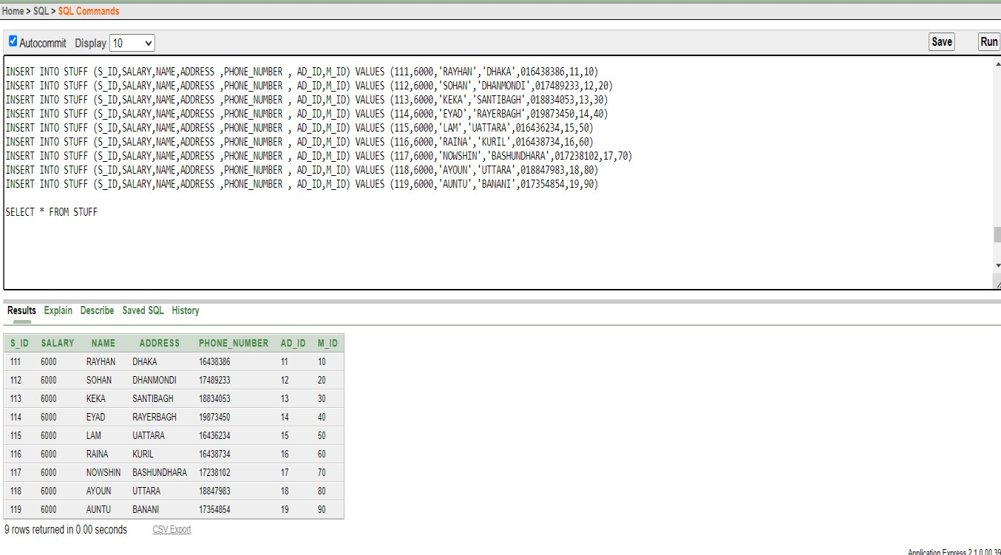

### 2.MANAGER

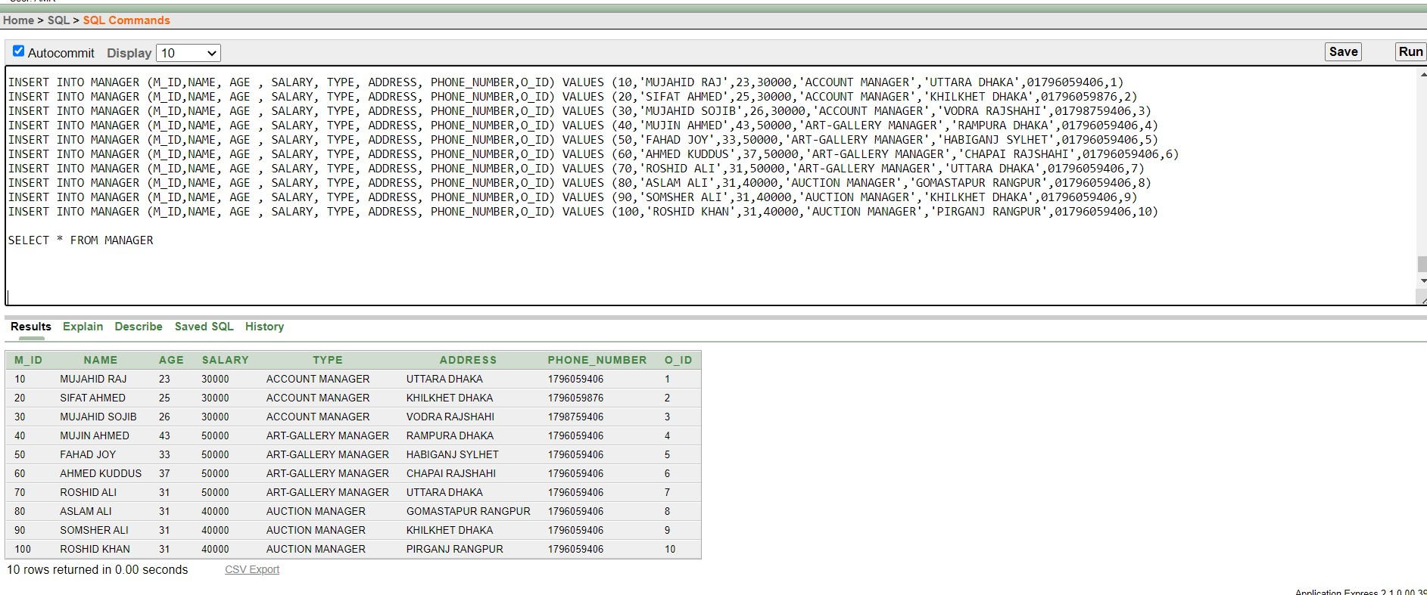

### 3.AGE DATE

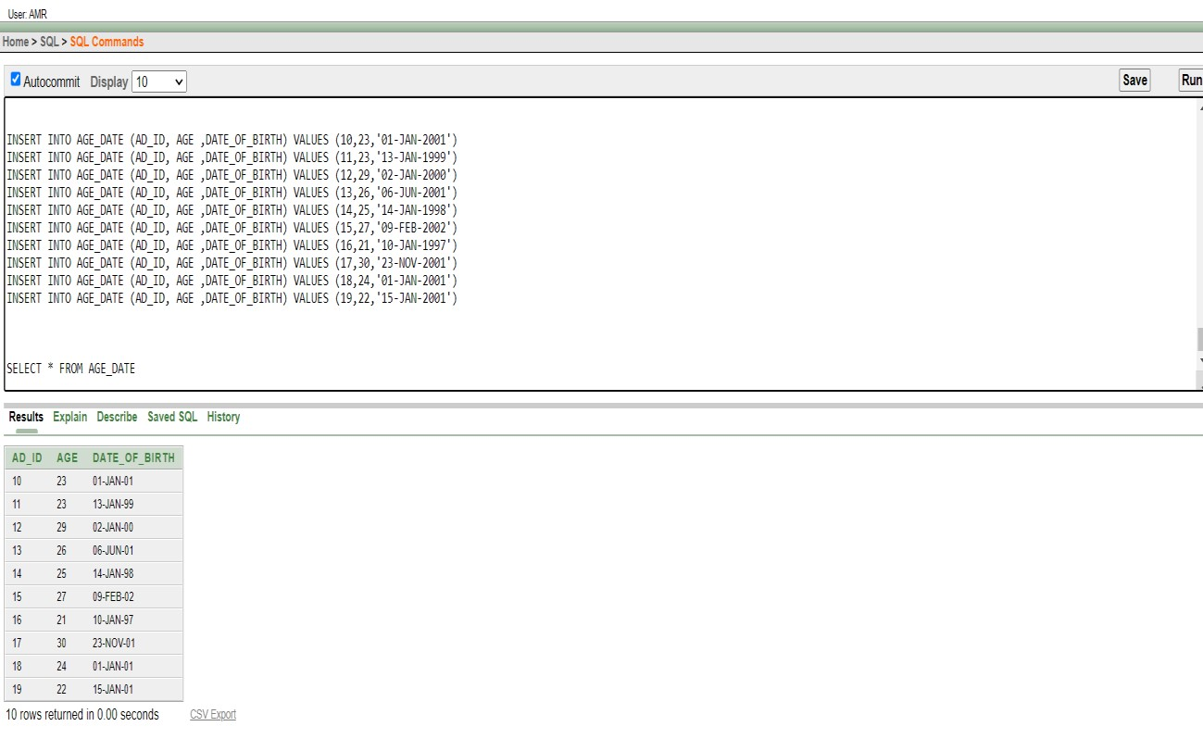

### 4.OWNER

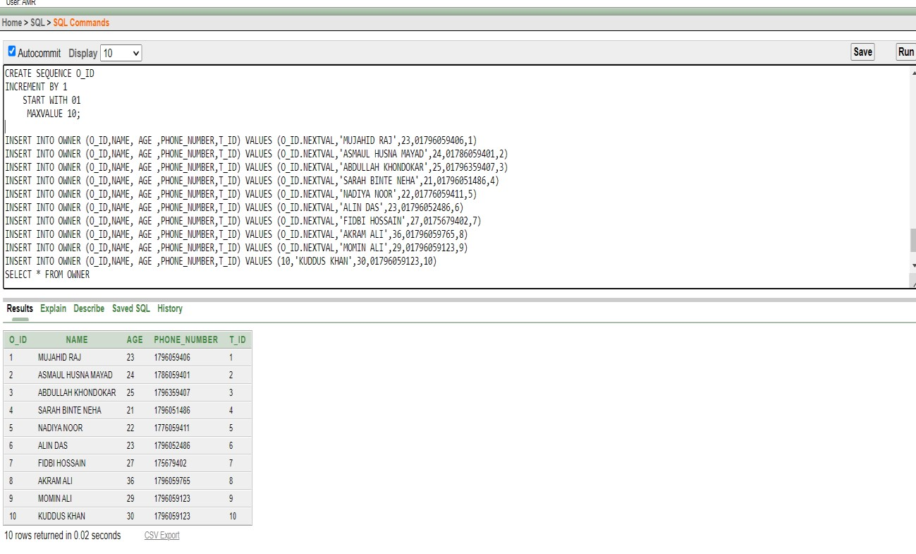

### 5.OWNER_ADDRESS

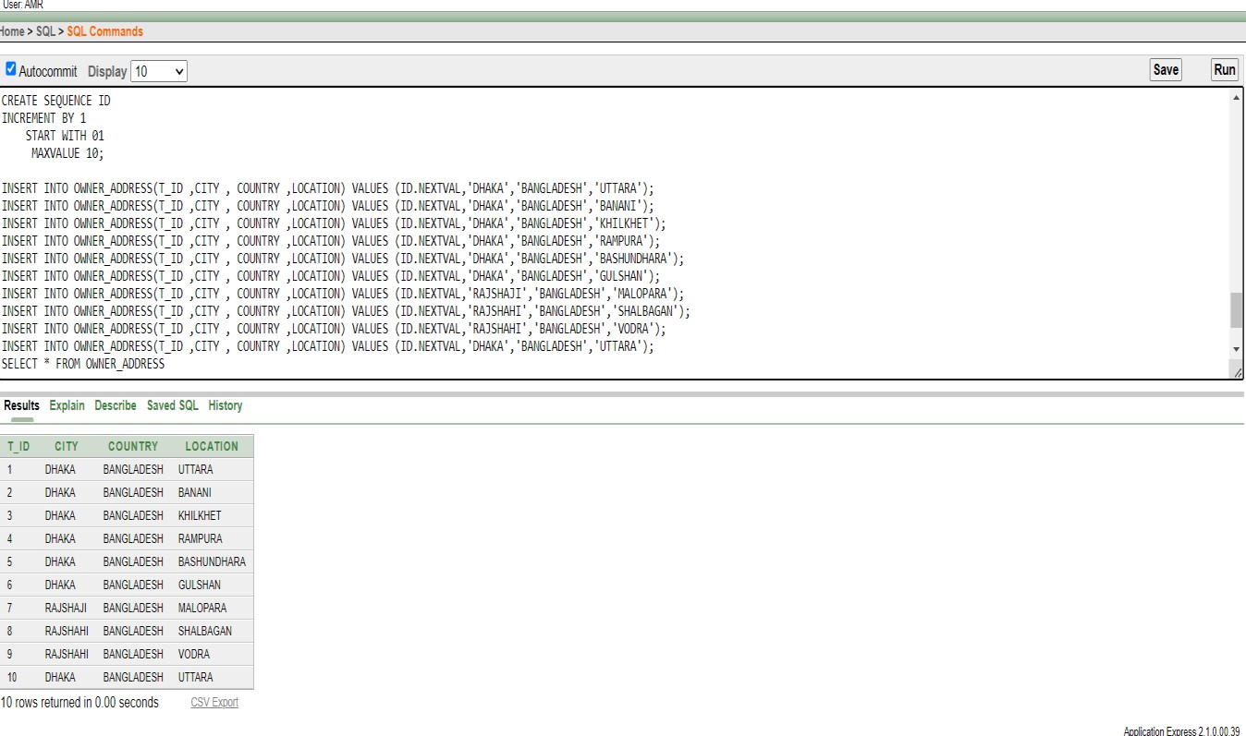

### 6.ART GALLERY

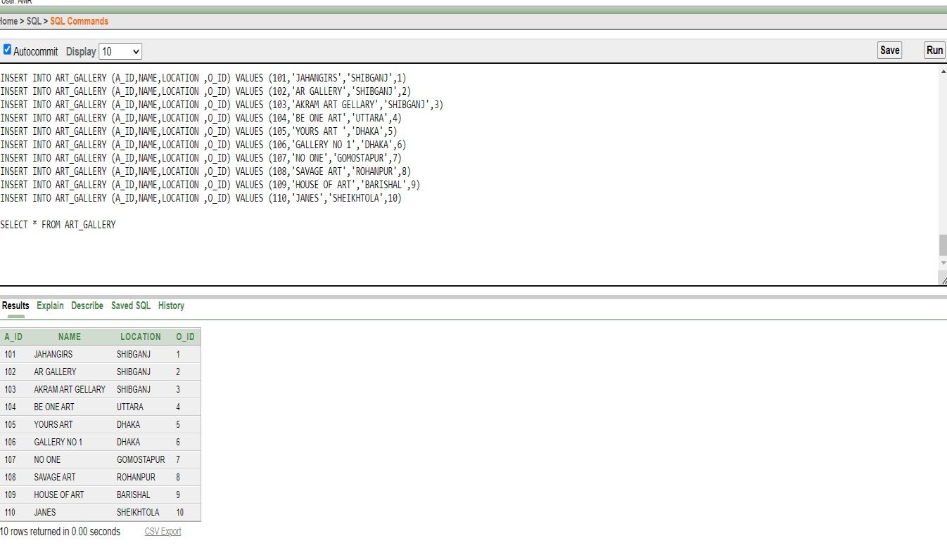

### 7.GALLERY VISITORS

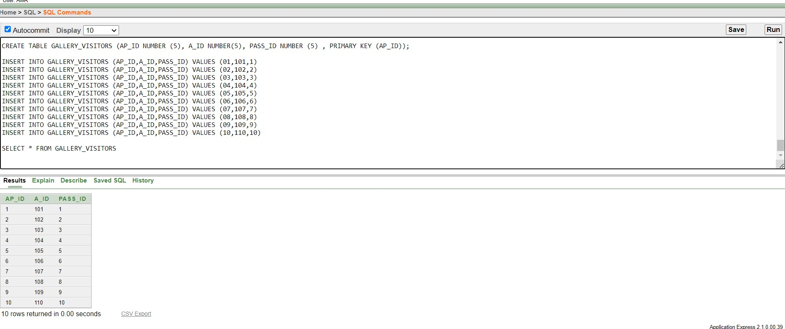

### 8.ART

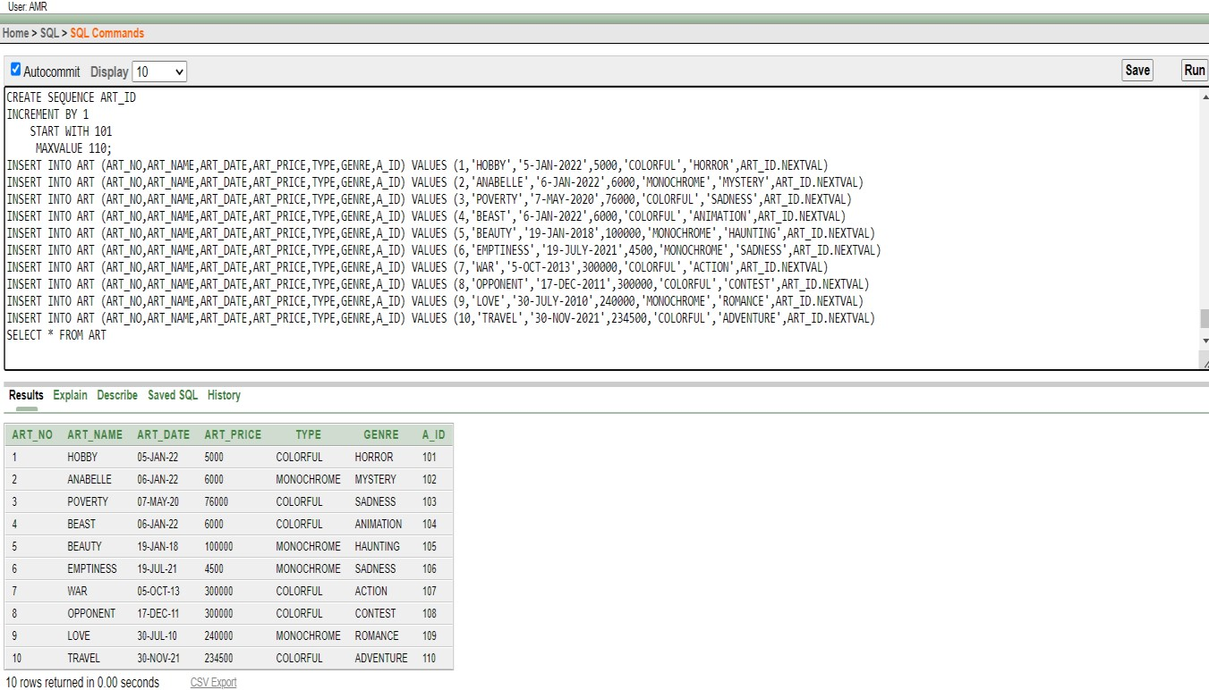

### 9.GUIDES

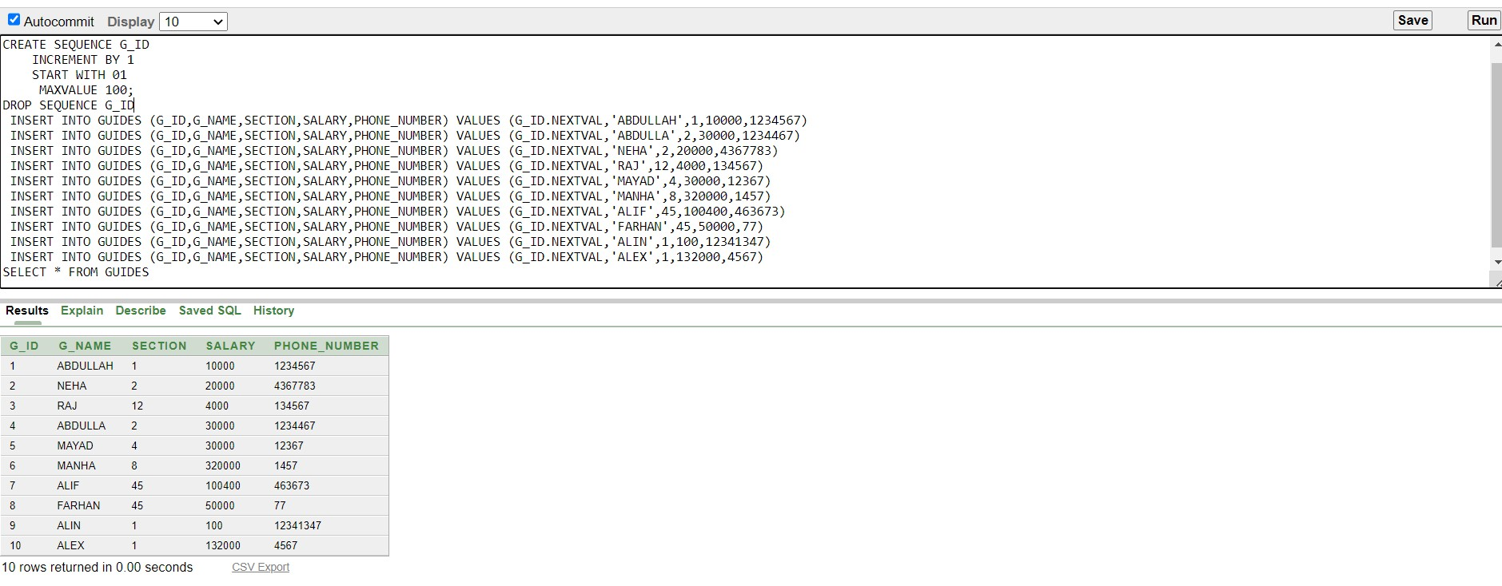

### 10.ARTIST

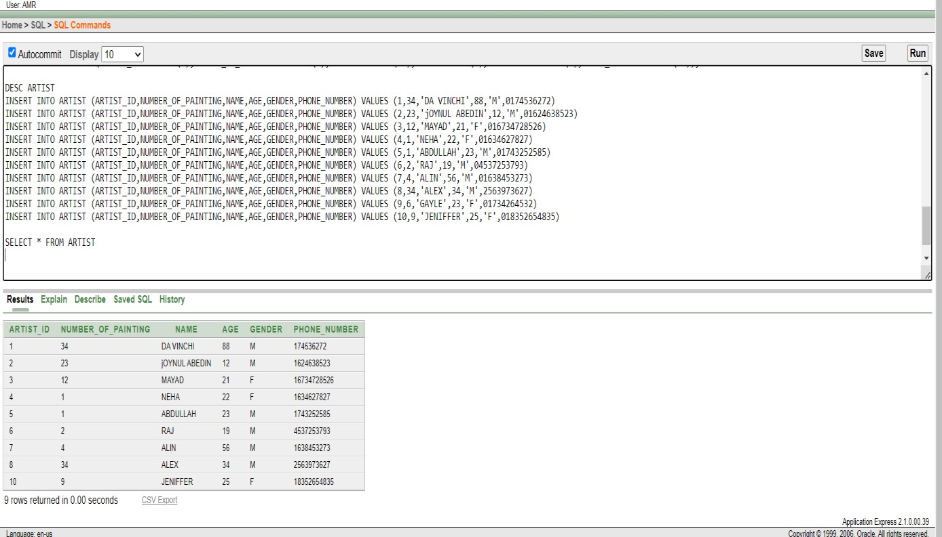

### 11.AUCTION

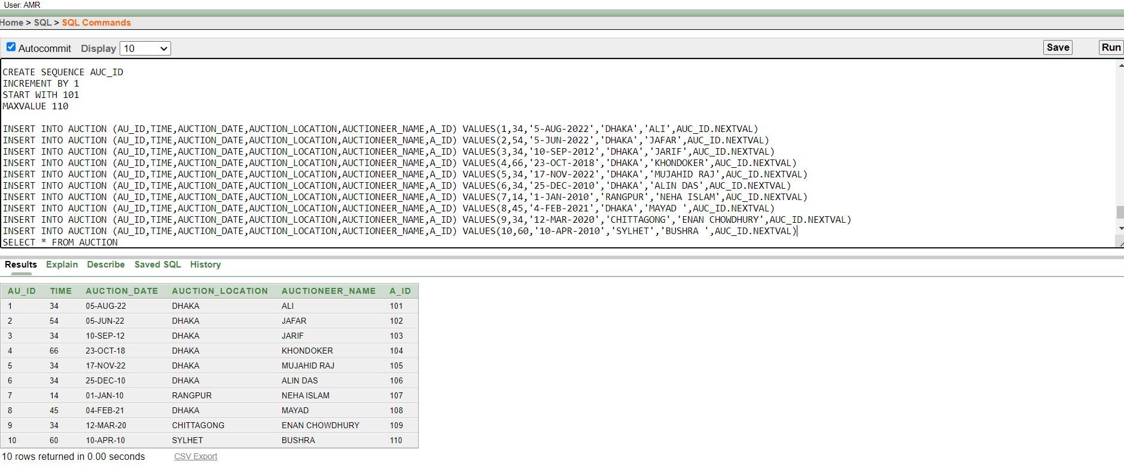

### 12.EXIBITION

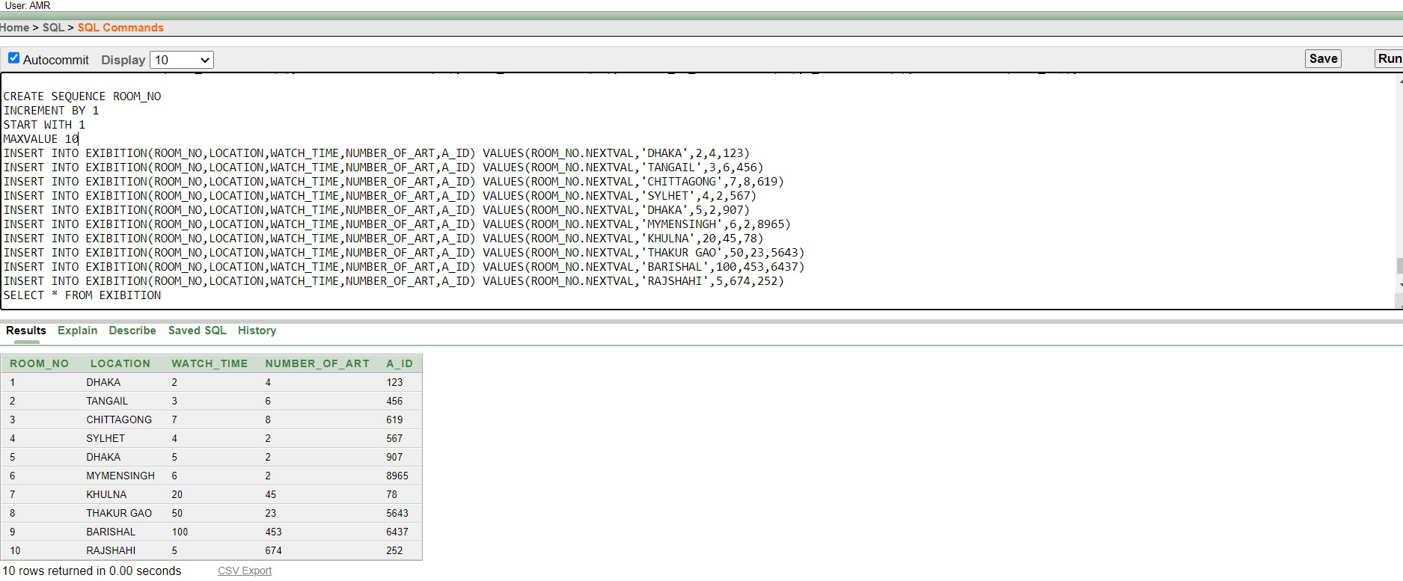

### 13.PAYMENTS OF BUYER

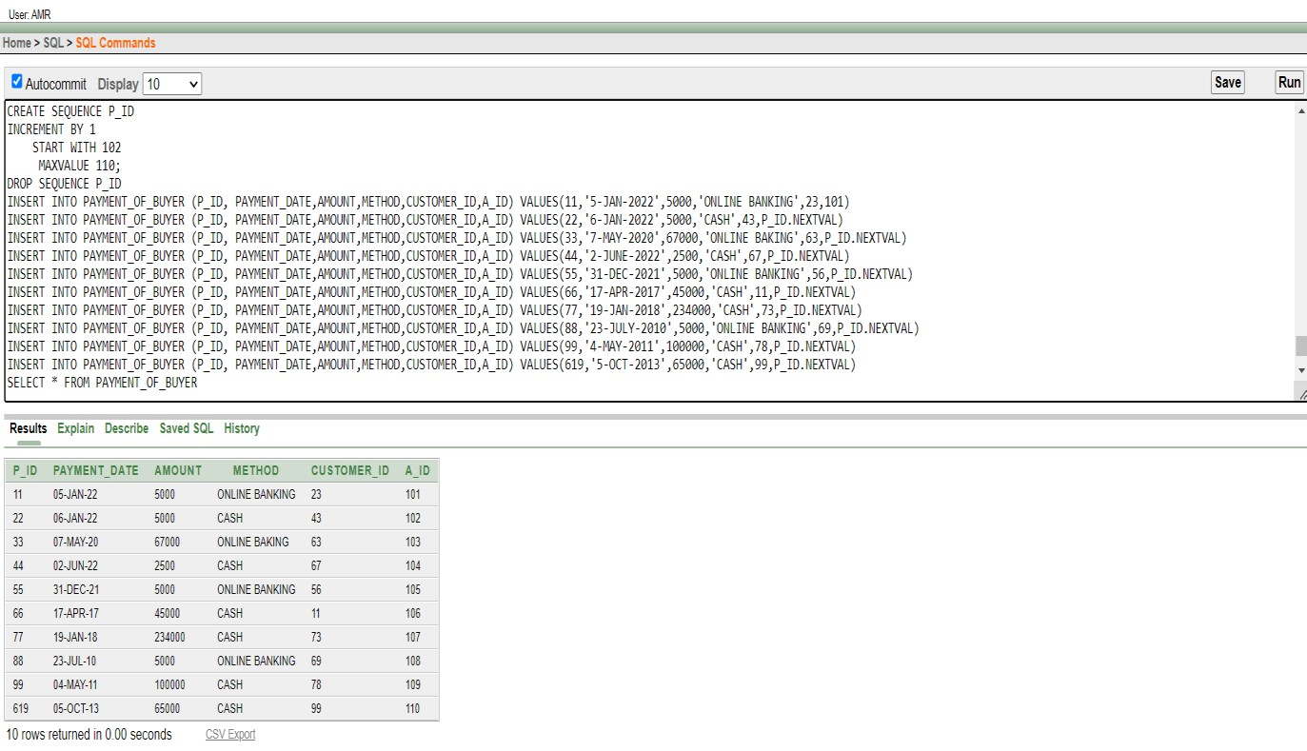

### 14.VISITORS

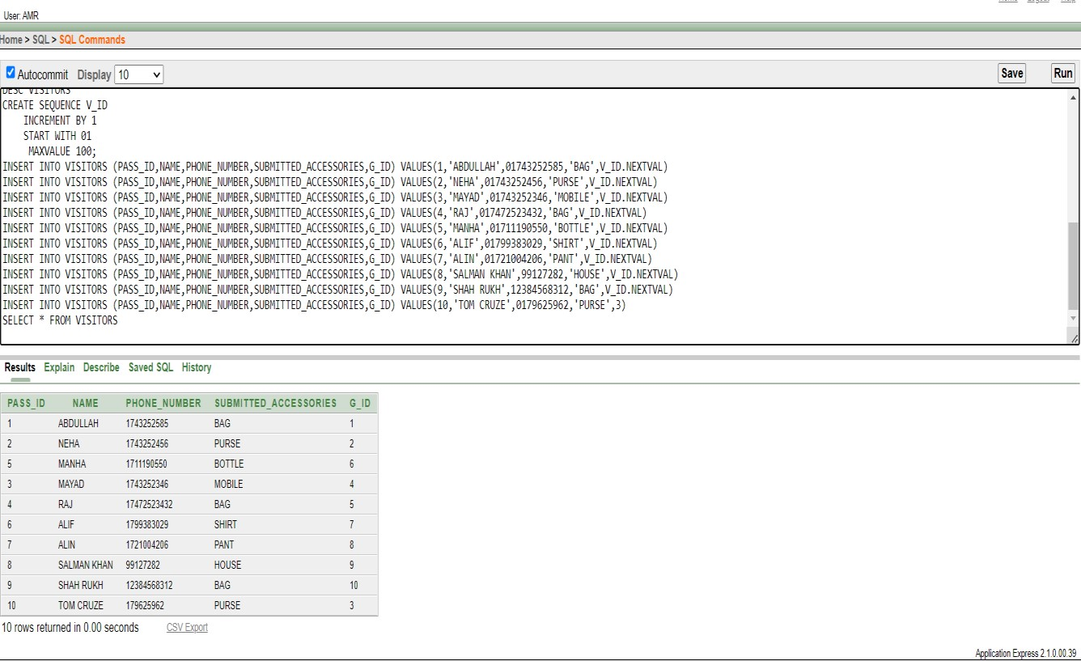

### 15.ART ARTIST

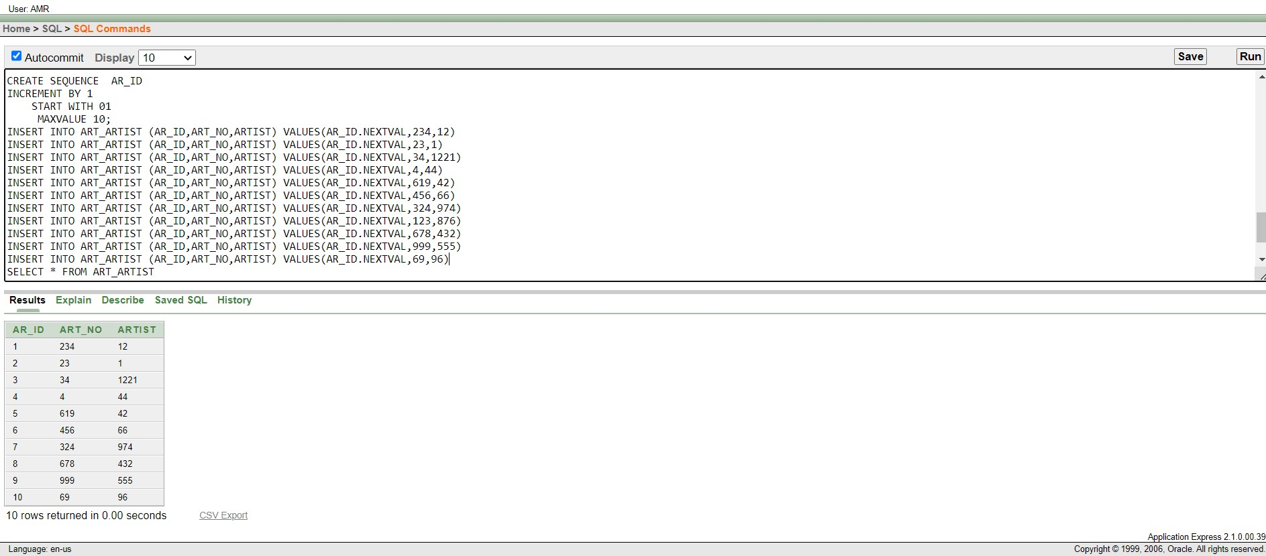

### 16.BUYER

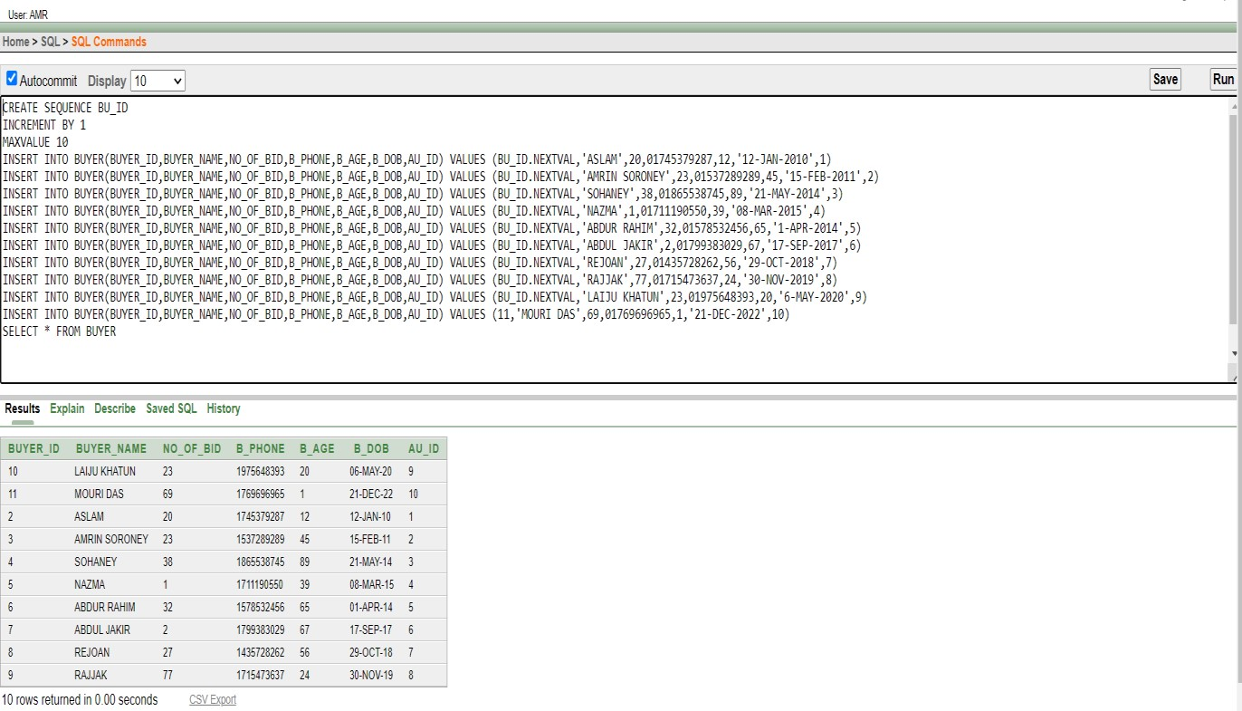

**QUERY WRITTING**

1. Display the name and salary for all managers who earn more than manager number 30 Answer : select name, salary from manager where salary > (select salary from manager where

m_id=30

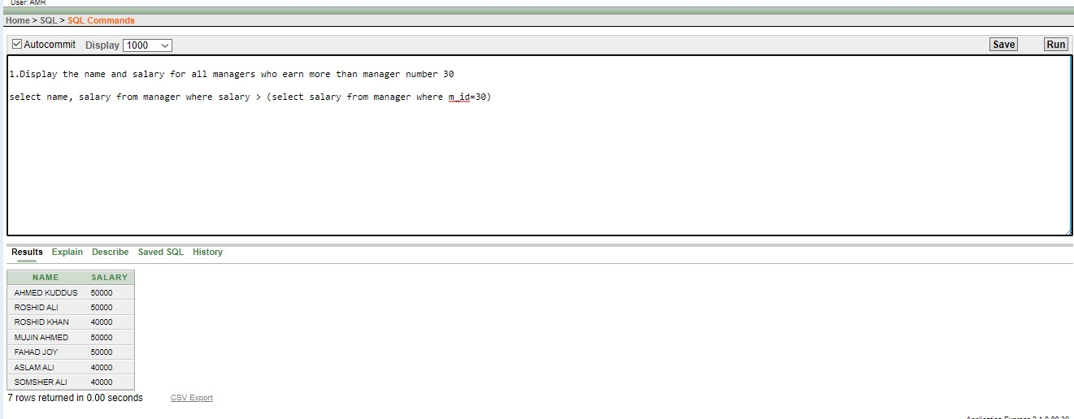

2 . Display the name and salary of all guides who’s job section is greater then guide name

Raj.

Answer : select g_name,salary from guides where section > (select section from guides where

g_name='RAJ')

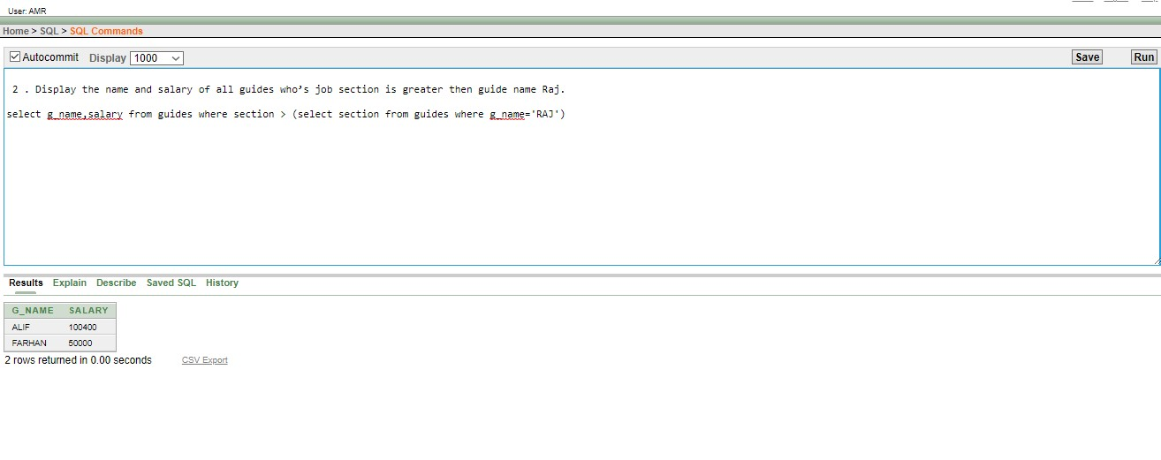

1. Display the name and age of all owner who’s age is less then owner name FIDBI HOSSAIN.

Answer: select name,age from owner where age < (select age from owner where name='FIDBI

HOSSAIN')

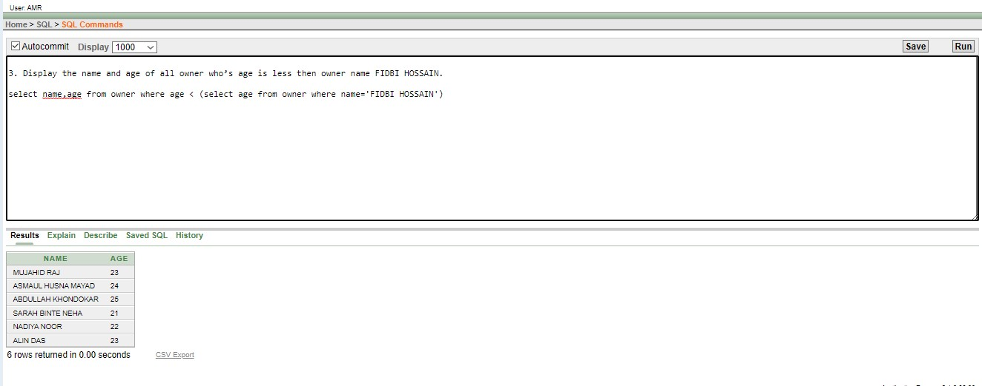

1. Display the name, age and number of art of all artist who’s number of art is less then the artist name RIAYAZ.

Answer : select name,age ,number_of_painting from artist where number_of_painting < (select number_of_painting from artist where name='RIAYAZ')

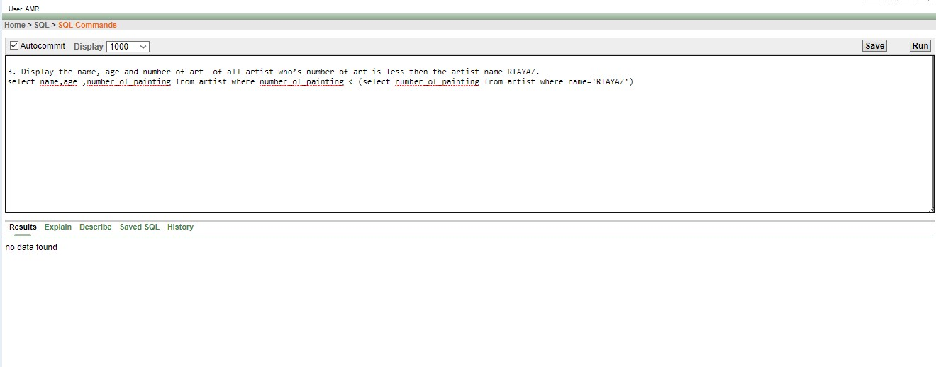

1. Display the name, salary and address of all stuff who’s salary is equal to the stuff who lived in uttara.

select name,salary , address from stuff where salary =(select salary from stuff where address='UTTARA')

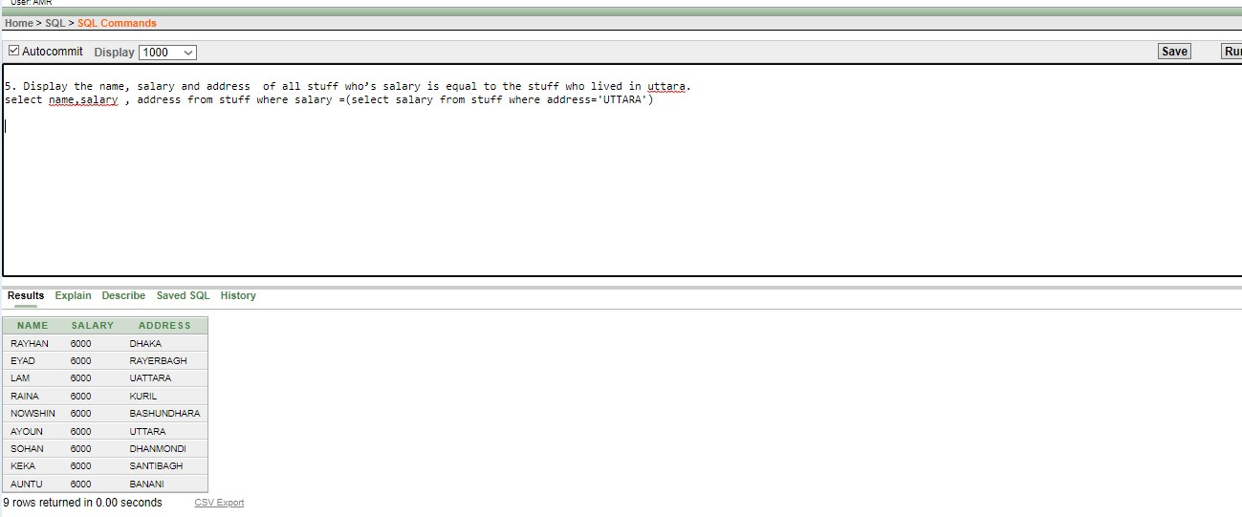

1. CREATE SEQUENCE STUFF_ID

INCREMENT BY 1

START WITH 1

MAXVALUE 10

NOCACHE

NOCYCLE

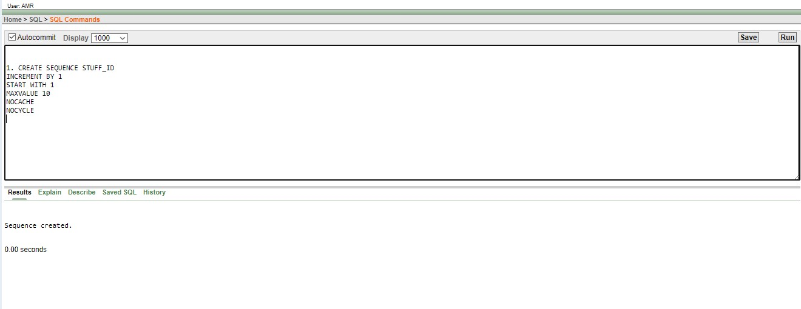

1. CREATE SEQUENCE OWNER_ID

INCREMENT BY 5

START WITH 55

MAXVALUE 100

NOCACHE

NOCYCLE

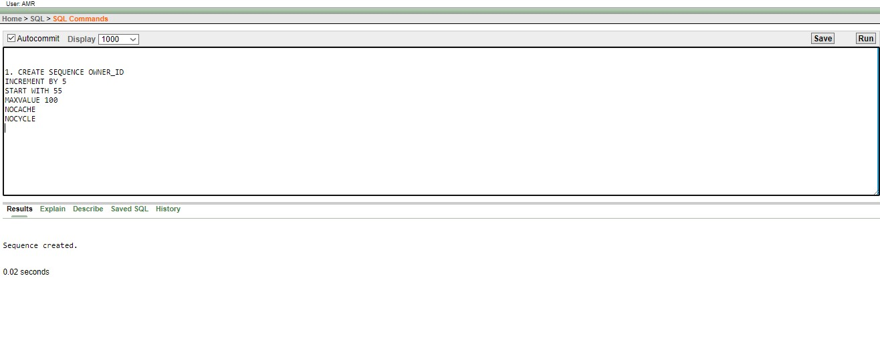

1 . create or replace view owner_info as select o_id,name ,age from owner where O_id=3

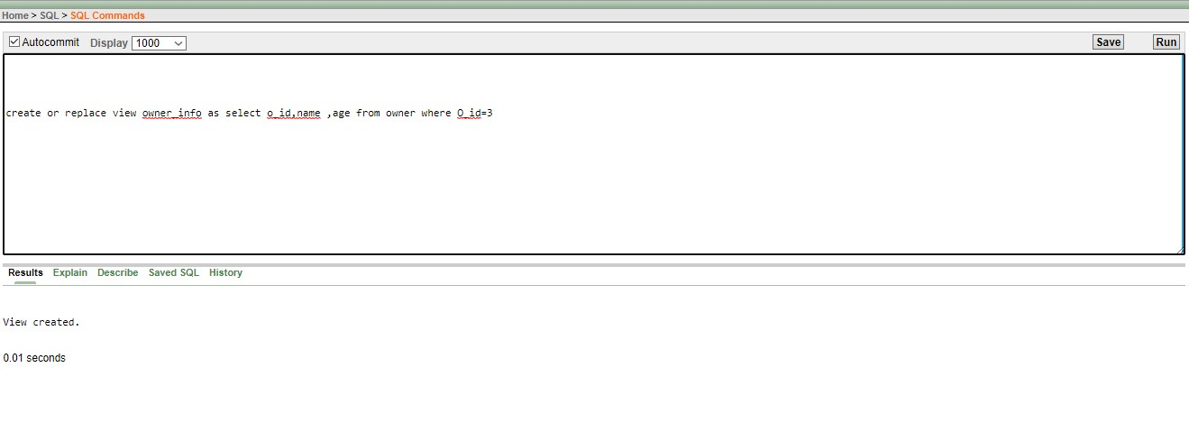

2create or replace view visitors_info as select name , phone_number , submitted_accessories from visitors where name='ABDULLAH'

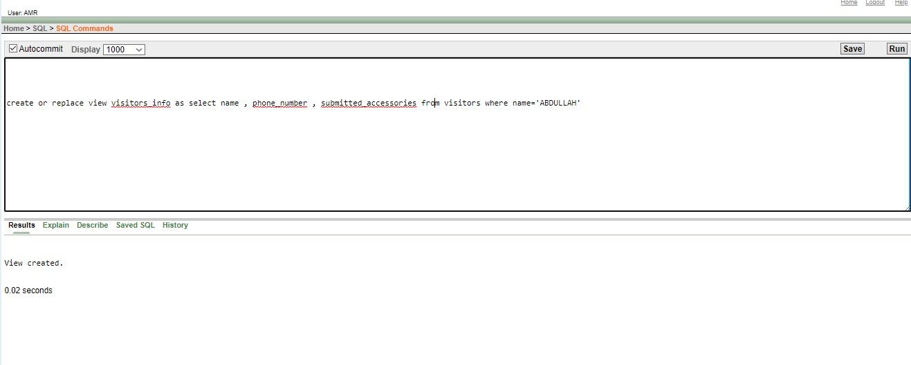

1.write a query to increment salary by 15% of all the staffs.

Ans: SELECT name,to_char(1.15*salary,'$99,999') AS "Salary" from STUFF;

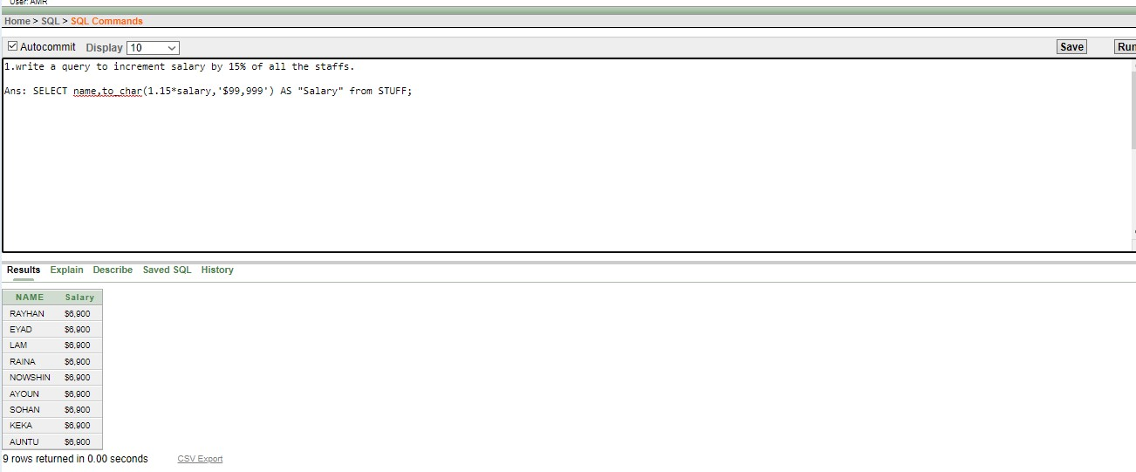

2.write a query to concat name and address of all staffs that have M_ID less than 70

Ans: select CONCAT(NAME,ADDRESS) FROM STUFF WHERE M_ID<70

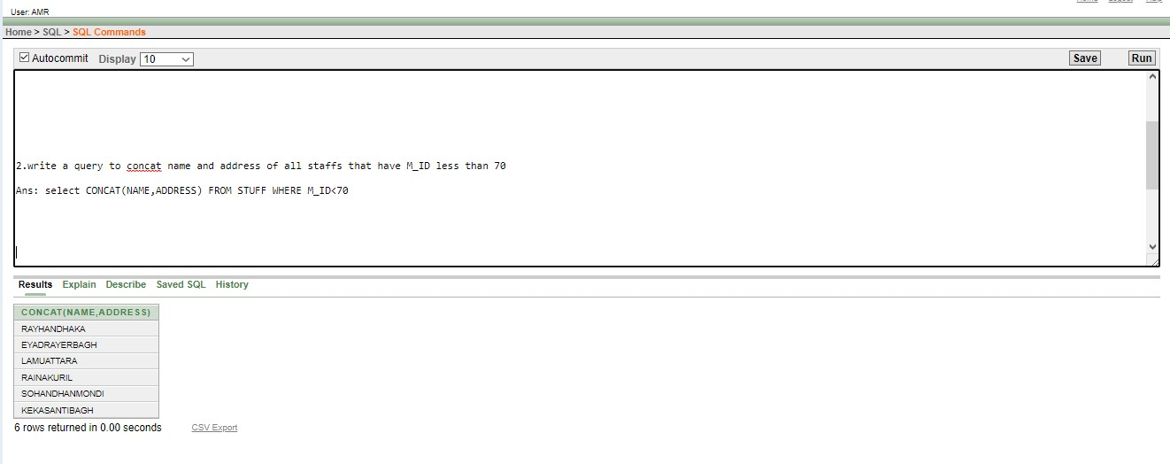

3.write a query to lower case the name of staff having 16 no A_ID

Ans: select initcap(name) from STUFF where AD_ID = 16

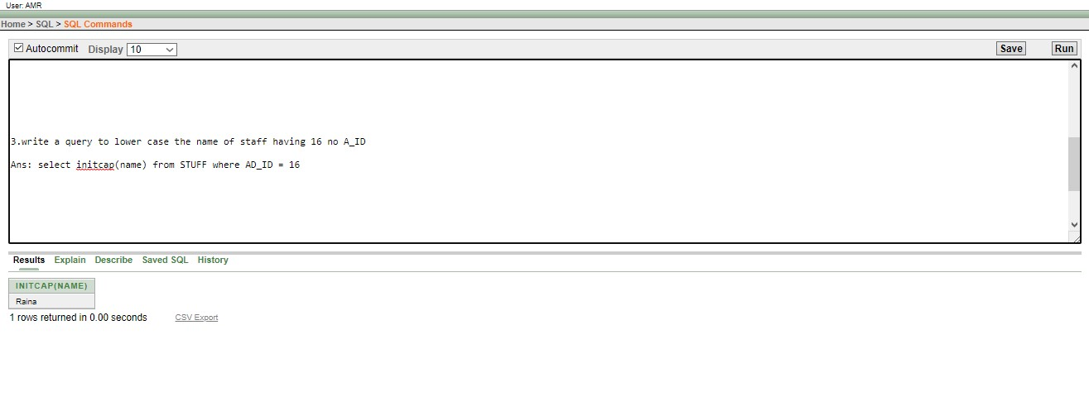

4.write a query about the current date and time as weeks from payment_of_buyer table

Ans: SELECT P_ID , (SYSDATE-PAYMENT_DATE)/7 AS WEEKS FROM PAYMENT_OF_BUYER

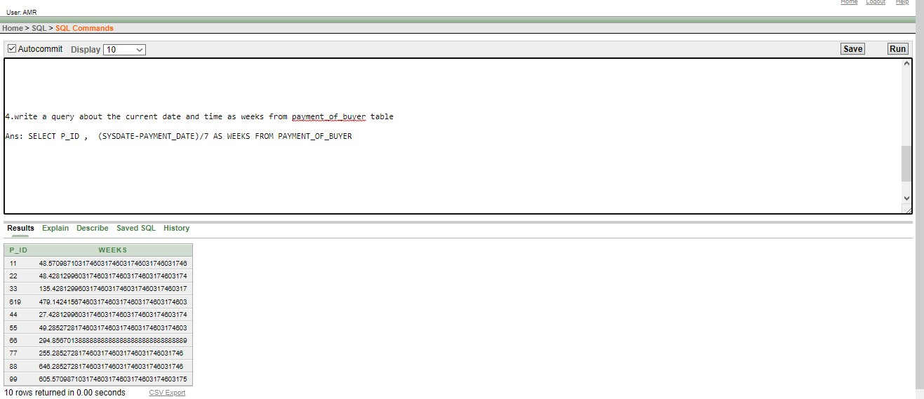

5.write a query to determine the months between specified dates

Ans.SELECT MONTHS_BETWEEN ('19-JAN-18','6-JAN-22') FROM PAYMENT_OF_BUYER

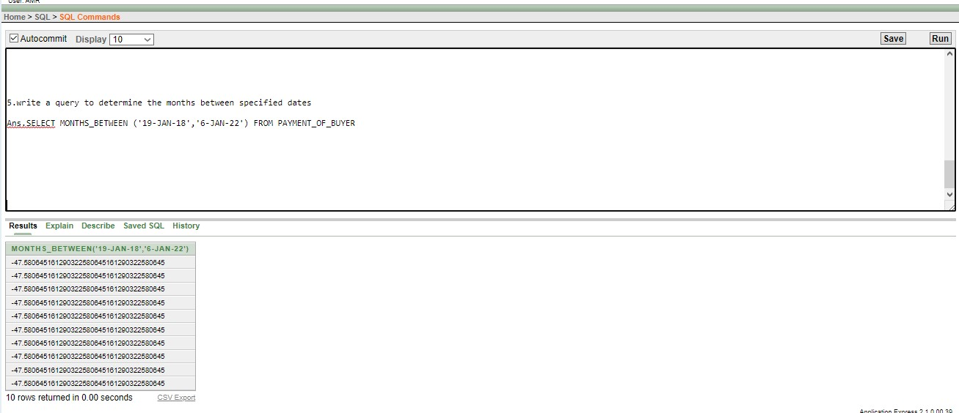

1.write a query to show max watch time for exibiton

Ans: select max(watch_time) from EXIBITION

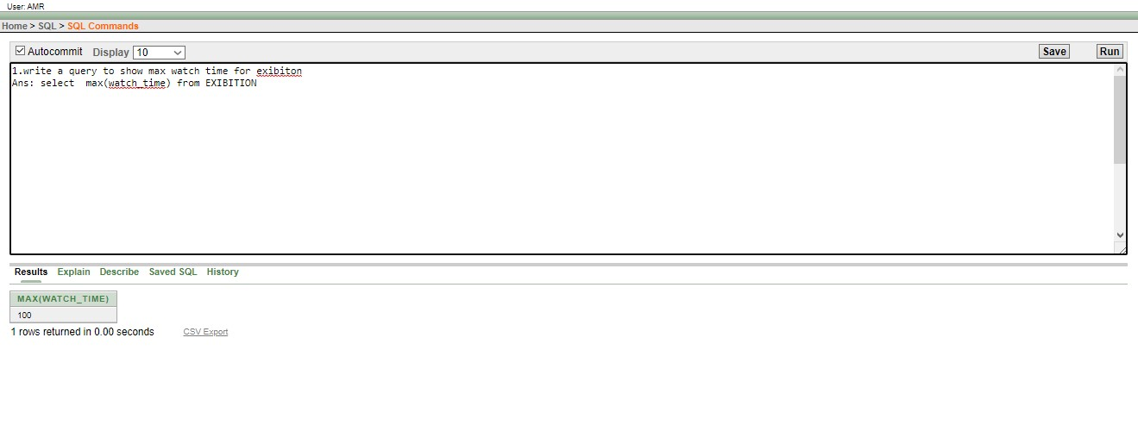

2.write the LOCATION,average number of art from exibition table

Ans: select AVG(NUMBER_OF_ART) from EXIBITION GROUP BY LOCATION

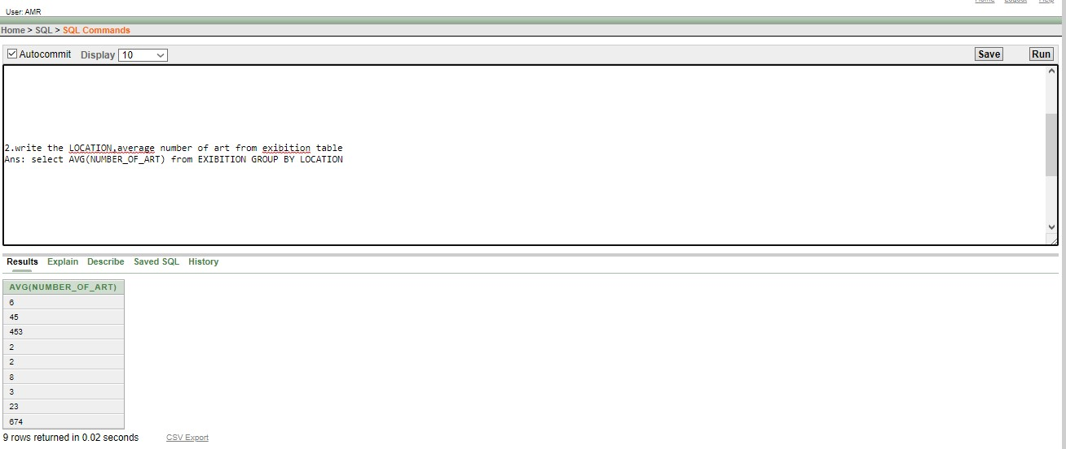

3.write the sum a_id of aal the rooms in exibition table

Ans:SELECT SUM(A_ID) FROM EXIBITION

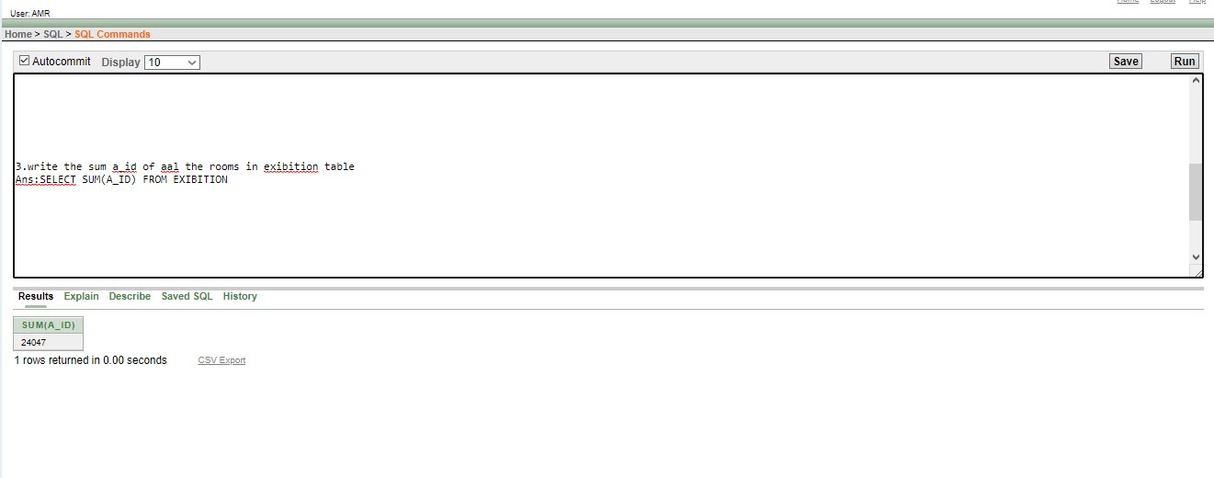

4.write a query to show the total rows in the guides table having 45 no. section

Ans:select COUNT(salary) from GUIDES WHERE SECTION = 45

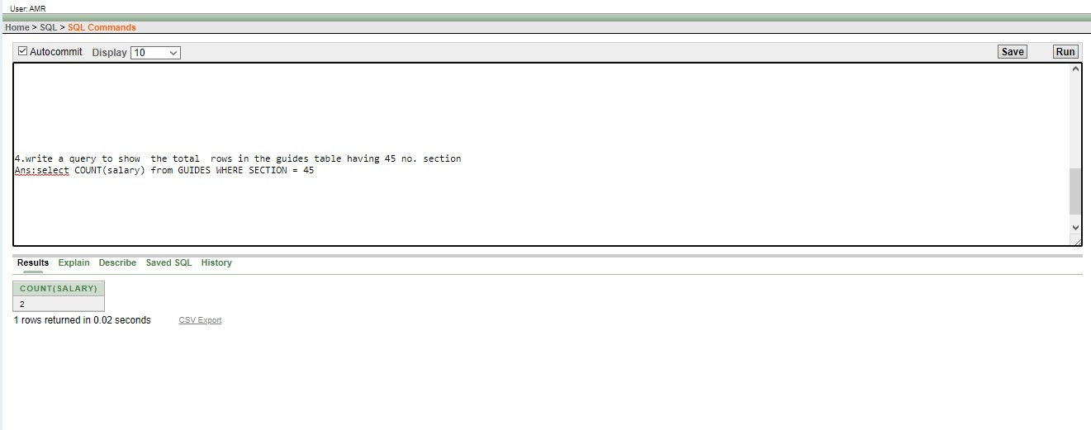

5.write a query to show the minimum salary and name of table GUIDES

Ans: select min(salary) from GUIDES group by G_NAME



EQUI JOIN 1 :

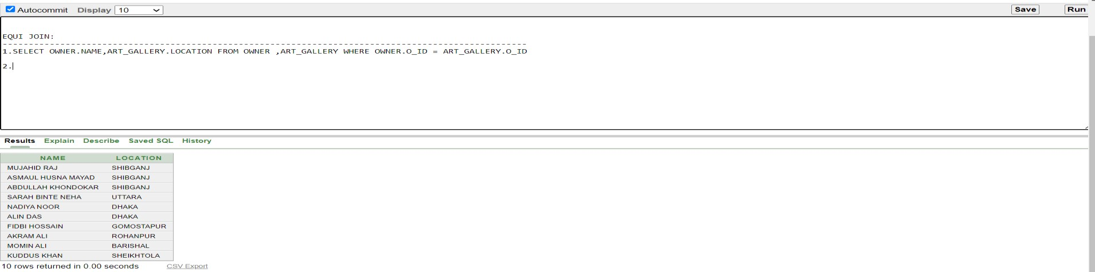

EQUI JOIN 02 :

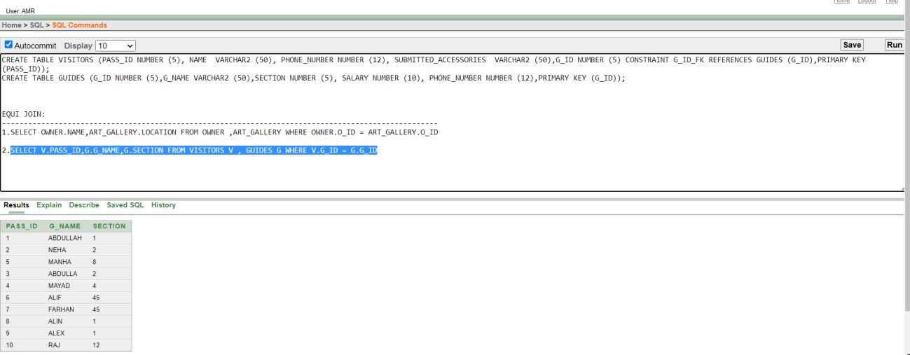

NON EQUI JOIN 01 :

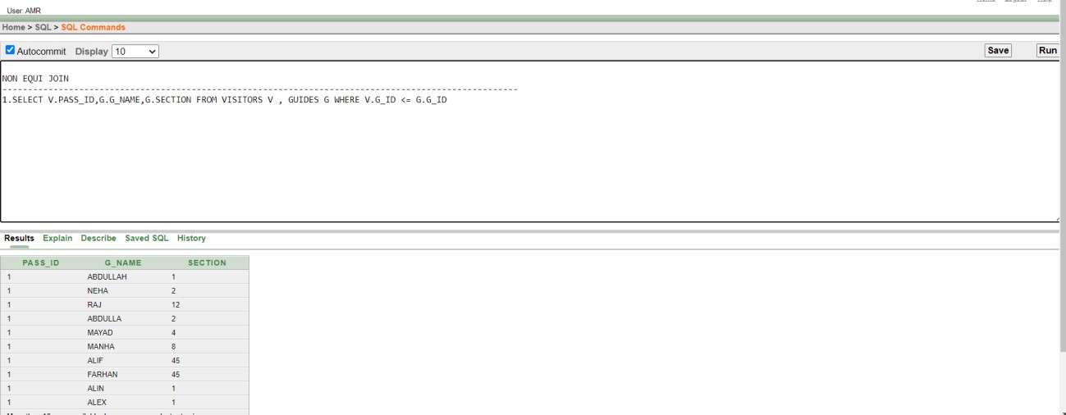

NON EQUI JOIN 02 :

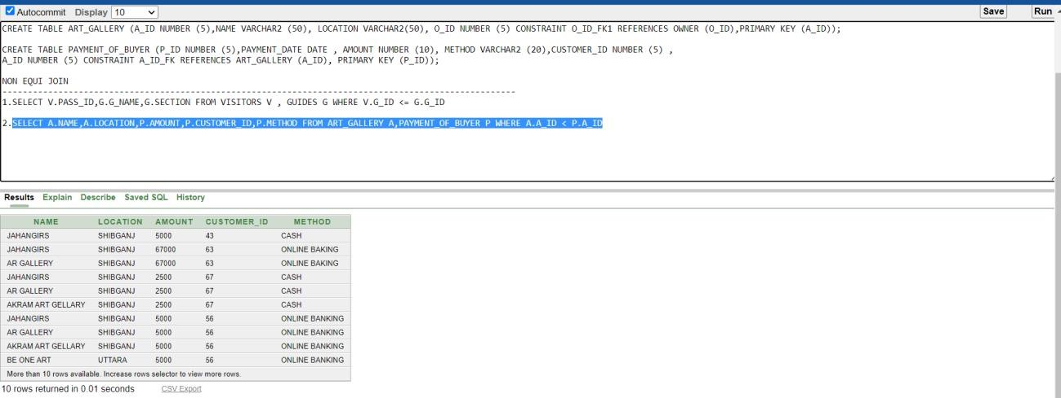

OUTER JOIN 01 :

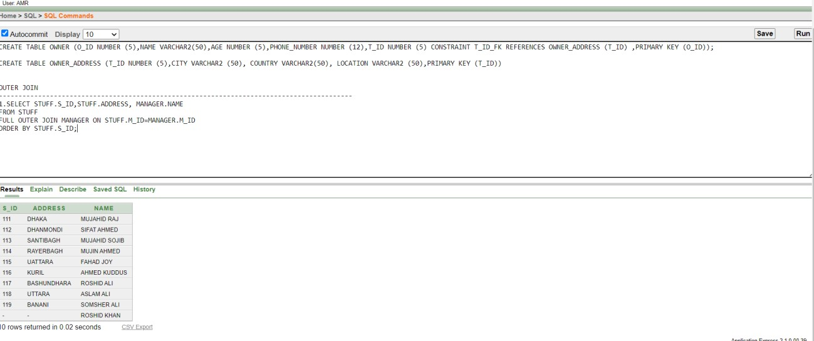

OUTER JOIN 02 :

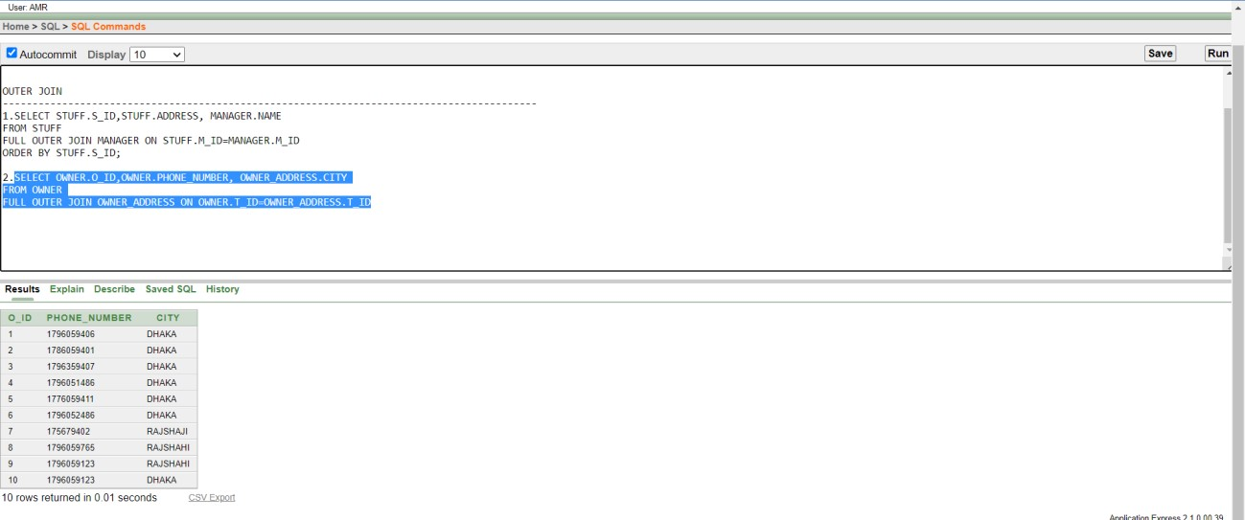

SELF JOINING 01 :

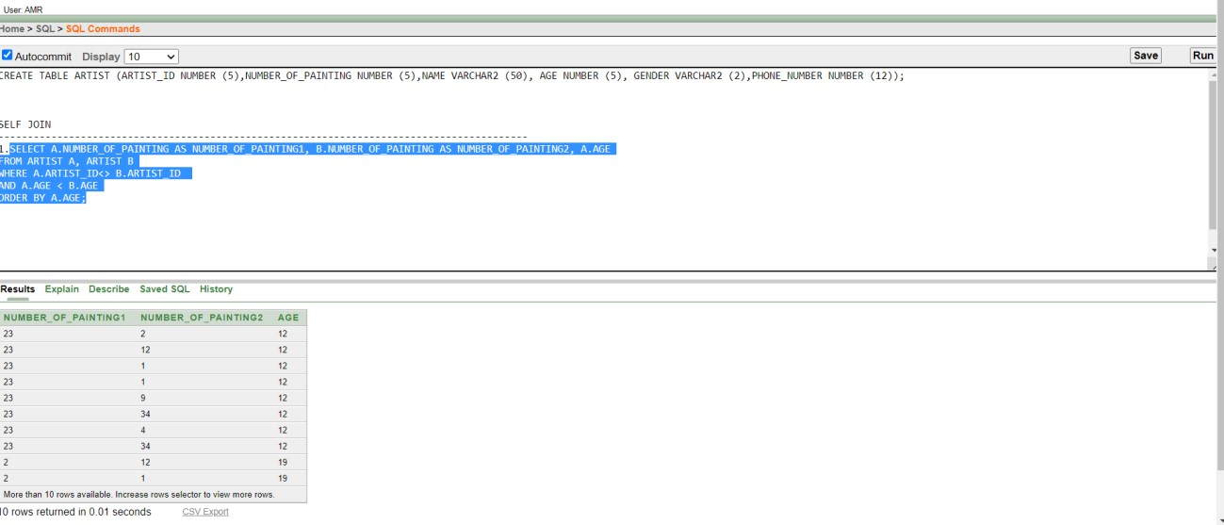

SELF JOINING 02 :

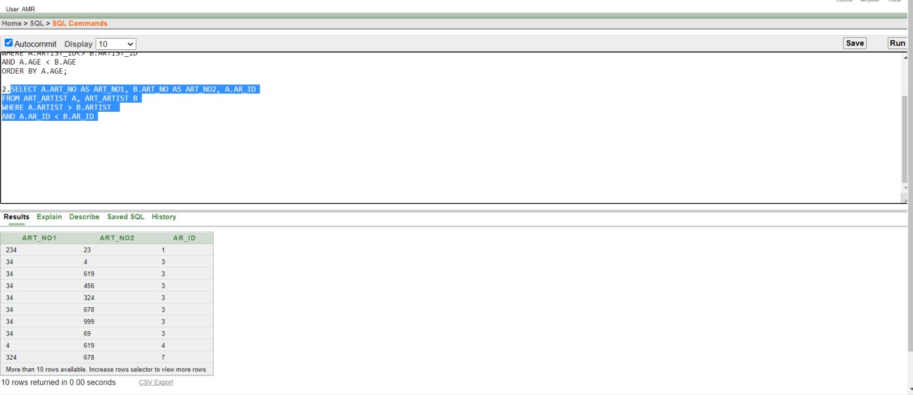

1 .WRITE A QUERY TO DISPLAY ALL THE STUFF

ANSWER :SELECT * FROM STUFF

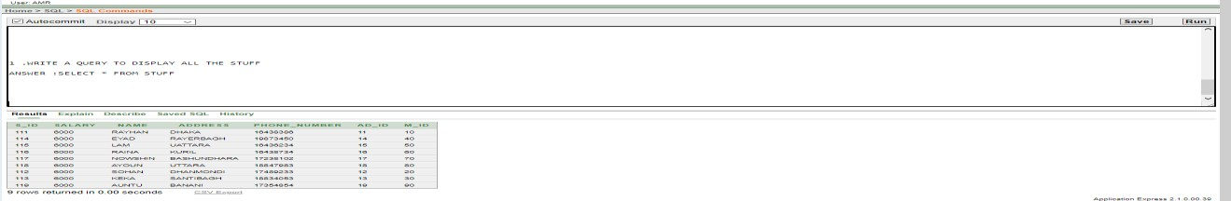

2.DISPLAY THE ART_GALLERY WHICH IS SITUATED IS GOMOSTAPUR

ANSWER : SELECT NAME , LOCATION FROM ART_GALLERY WHERE LOCATION = 'GOMOSTAPUR'

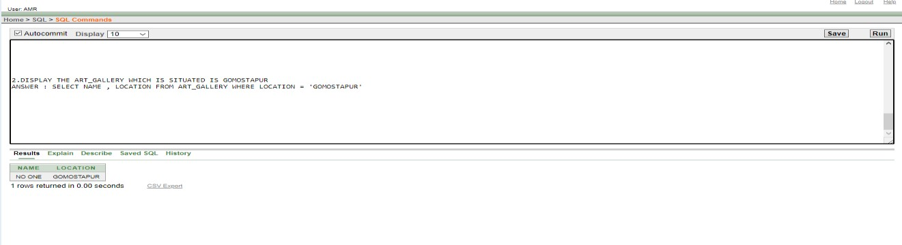

3.DISPLAY THE MANAGER NAME AND AGE WHOSE SALARY IS 30000 OR MORE .

ANSWER :SELECT NAME , SALARY , AGE FROM MANAGER WHERE SALARY >= 30000

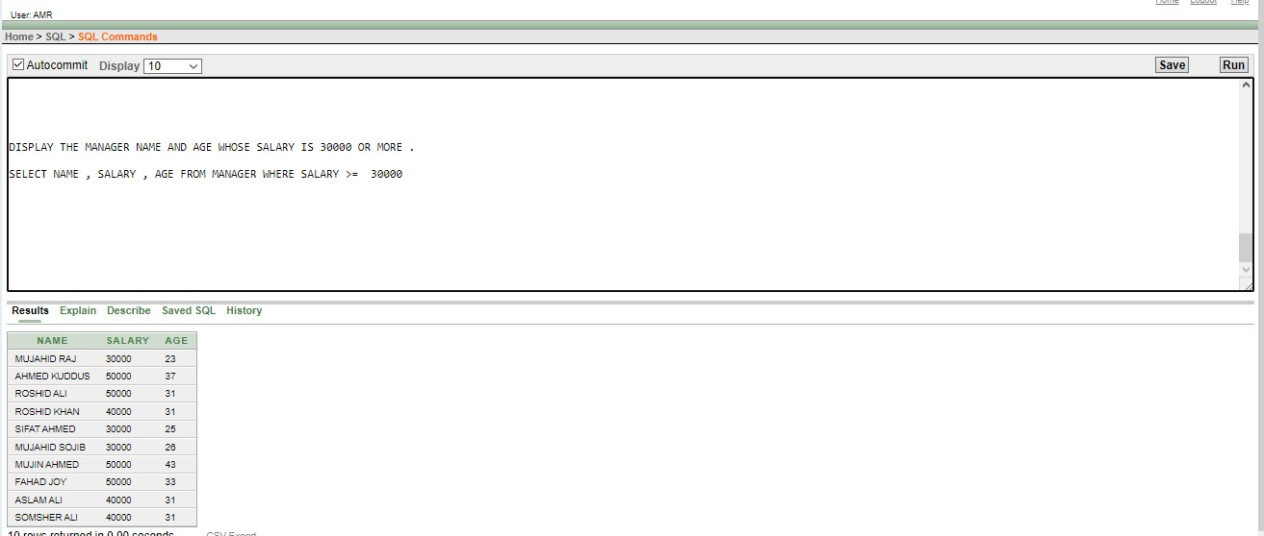

1. . DISPLAY ALL THE ARTIST NAME FROM TABLE ARTIST

ANSWER : SELECT NAME FROM ARTIST

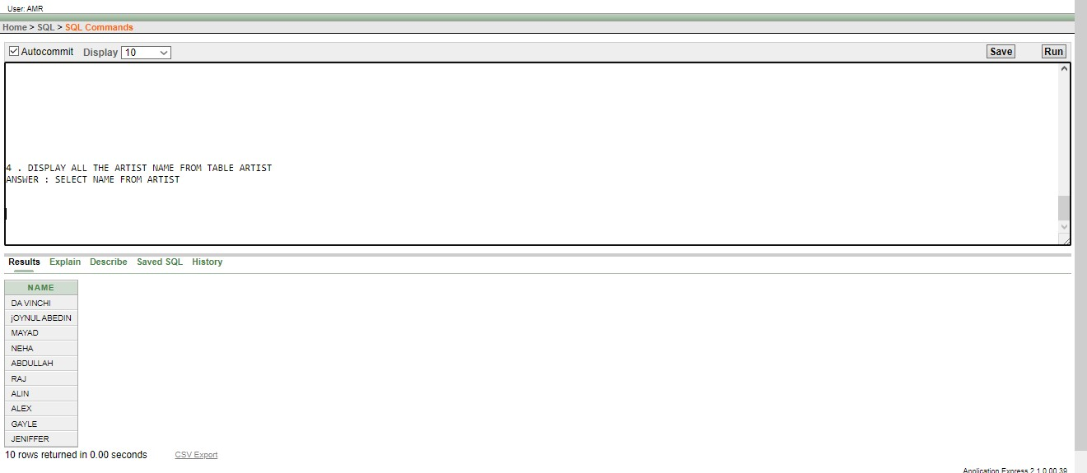

1. . DISPLAY MANAGER ID WHOSE NAME IS MUJAHID RAJ.

ANSWER : SELECT M_ID FROM MANAGER WHERE NAME= 'MUJAHID RAJ'

